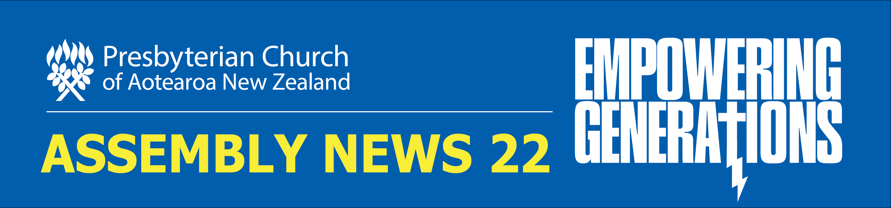

Wednesday 27 April – Friday 29 April

Wednesday 27 April

Second online Assembly opens
The Special Assembly that began today is the second online Assembly held by the Presbyterian Church. The first online Assembly was the shortened General Assembly held last year. The ongoing Covid-19 pandemic has seen the Church adapt, learn and upskill to create new ways to meet via online platforms. See images here from 'behind the scenes' at Hope Christchurch where the technical team is working hard; a huge effort has gone into holding the event electronically. Images below are of the 'top table' and the screens of Assembly Commissioners before them.

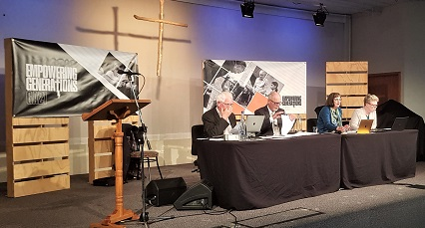

Opening Service
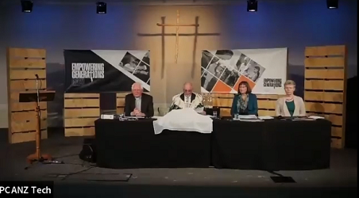
Watch video of the opening service of Special Assembly, led by Moderator Right Rev Hamish Galloway.

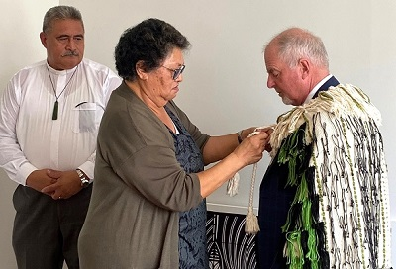
Transfer of Te Korowai Tapu
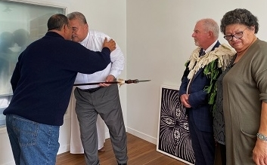
Last year, due to the online service, it was not possible to have the usual ceremony and service for installation of the Church's Moderator involving the transfer of a ceremonial cloak (Te Korowai Tapu) and the laying on of hands by past Moderators, before the gathered Commissioners of the Assembly. The installation is usually preceded by a powhiri.
So, in March this year, Moderator Right Rev Hamish Galloway and Very Rev Fakaofo Kaio gathered with Marina Rakuraku, Moderator of Te Aka Puaho who removed Te Korowai Tapu from Very Rev Fakaofo Kaio’s shoulders, and placed it over the shoulders of the Right Rev Hamish Galloway. Rev Tamiana Thrupp of Te Aka Puaho led a karakia.
Gifts were presented by Te Aka Puaho to previous Moderator, the Very Rev Fakaofo and to his lovely wife Mrs Ruth Kaio.
Download the PowerPoint slideshow of the transfer of Te Korowai Tapu played at the opening of the Special Assembly on 27 April 2022. The music is ”Korowai Tapu” by Rev Malcolm Gordon, from Songs for the Saints.

SA22 Business Begins
A number of Procedural Motions enabled SA22 business to proceed this afternoon.
The Assembly roll was accepted, as were reports and proposals printed in the Assembly reports - the working documents of the online Assembly.
Procedural motions were agreed without debate.
Standing orders were adopted with the deletions of the last lines of clauses 17 and 23. Leave was granted for changes to be made to recommendations, or to withdraw recommendations, as listed in Section C of the White Book.
Key positions that enabled the Assembly to proceed were ratified. Chris Wiltshire, Rev Marty Redhead and Brad Kelderman were appointed timekeepers, Rev Andrew Howley was appointed scrutineer and Rev Shona Bettany was appointed Deputy Clerk until the close of this meeting. The Facilitation Group under Standing Order 24 comprised the Revs Chris Elliott, Anne Stewart and David Coster.
Knox Church in Dunedin, St Albans in Christchurch and Nawton Church in Hamilton were granted leave to meet during the Special Assembly.
The Memorial Minute for the Rev Ned Ripley was placed on the records of the Assembly.
The following associates were recognised: Rev Alistair McBride, Ms Marina Robati-Mani (Assembly Business Work Group), Ms Marilyn Wallace, Rev Dr Kerry Enright (Book of Order Advisory Committee) and the Very Rev Richard Dawson.

BOO wording clarifies property aspect of dissolution
Special Assembly today approved a clarification to Chapter 5 of the Book of Order, which seeks to remove any doubt about the rights of a congregation to have a say in how their property is treated during discussions about dissolution.
After a church council has applied to a presbytery to be dissolved, a second congregational meeting is held with a Commission of the presbytery. This meeting discusses the consequences of dissolution and it provides congregational members a chance to voice their concerns.
“Although it has been implicit in the existing provision that the hopes and concerns expressed by the congregation (wishing to dissolve) to the presbytery Commission include their hope and concerns about the property of the congregation, this amendment ensures that such views will be heard,” explains Marilyn Wallace, Acting Convenor of the Book of Order Advisory Committee.
Today’s amendment to section 5.9(2) to add: “including in relation to property” after “their concerns and hopes” is the result of questions and discussion at the General Assembly 2021. Proposals put forward then were withdrawn from further consideration.
The change has been adopted as an interim provision in place until the next General Assembly meets in 2023 and will be remitted to presbyteries and church councils.

PressGo
Today the role of PressGo in sharing resources nationally, particularly through the administration of the Mission Enterprise Fund, was debated.
PressGo was established by the General Assembly in 2008 to play a role in the culture of generosity and sharing resources nationally. Since then it has made grants of $3.5m to 119 applicants, with sums ranging between $500 and $500,000 each. The Assembly was asked to affirm this continued role since there were those who felt PressGo’s national focus harked back to an era before larger presbyteries and thus was no longer necessary. However this was refuted. Many attendees spoke of the invaluable assistance PressGo had given their presbyteries in addition to the local support they had received
The motion that PressGo’s role in sharing resources nationally, particularly though the administration of the Mission Enterprise Fund, be affirmed was carried 138 to 8.

The Doctrine Core Group
A motion that for the sake of greater clarity and shared understanding, a statement on the formula, fundamental doctrines and liberty of conviction, as set out in Appendix 1 to the DCG’s Assembly report be adopted was put to the Assembly.
All speakers spoke in favour of this motion which they hoped would dispel uncertainty and help enhance the Church's underlying unity and cohesion. One speaker suggested it was important to continue to be reminded of what had been agreed in the past
The motion was carried 133 to 10 votes.
Leave was granted to withdraw the motion that the material on the Church website about Statements of Faith be revised, as set out in Appendix 2 to the Doctrine Core Group’s report, so as to align with Book of Order Regulation 1.1 (1-7).
Hate Speech
It was voted that leave be granted to introduce the motion that in relation to proposed ‘hate ‘speech’ legislation, it be resolved:
A) That in consistency with biblical teachings, this Church rejects all racism, extremism, hatred, toxic speech, incitements to hatred, and incitements to violence, and agrees that dangerous, threatening and hostile speech should be constrained by law.
B) That this Church is concerned for society’s foundational liberties of thought, religious belief and expression, as set forth in the New Zealand Bill of Rights and urges Parliament to ensure there are very clear definitions in the legislation distinguishing between truly dangerous hate speech and the general rights of all New Zealanders to hold and express diverse beliefs and opinions, even though any such beliefs and opinions may sometimes be seen as disagreeable or offensive by some.
C) That this resolution be communicated to the Prime Minister, Minister of Justice, Select Committee and other Members of Parliament.
The backdrop to this motion was the hate speech legislation that was to have been put to Parliament this year but has since been shelved. The purpose of the motion was to balance the competing demands for speech to be free of hate while at the same time safeguarding the basic liberties of freedom of expression. As one speaker explained that they are asking for the right of belief and opinion to be protected for everyone, including those opposed to the Christian faith.
The motion was carried 126 to 17.
Terms of Reference
The motion that the Terms of Reference of the Doctrine Core Group be amended by the addition of a new final sentence: “The Doctrine Core Group may bring to the attention of the Church or General Assembly public matters which have significant implications” was suspended pending an investigation into the terms of reference of the DCG. This would require checking the GA 2018 decision on this issue. It was hoped further clarification would be available tomorrow.

CPT offers pathway to buildings that enhance mission
The Church’s Property Trustees have laid down a challenge that significant changes to the Church’s property portfolio need to be made – and soon.
“We are concerned that the Church’s properties are no longer fit for the purpose of supporting ministry in the 21st century,” says CPT Convenor Rev Andrew Souness. “Too many of our properties are old, cold and uninviting. They are expensive to maintain and insure, earthquake-prone and single-use. Only a third of them have an acceptable earthquake rating.”
The Trustees hold titles with an estimated value of $1 billion and they also oversee capital proceeds from property sales, which make up nearly 40% of funds in the Presbyterian Investment Fund. Recent, exciting new builds show what is possible, says Andrew.
“These multipurpose buildings are a joy to be in and are easy to maintain. They’re inspiring.”Assembly heard today that the Trustees believe change is possible, but progress so far has been slow and uncoordinated. The Church needs to act more collectively and more strategically.
What that means in practice is that presbyteries, the Church Property Trustees, and the Synod of Otago and Southland and its joint Property Working Group, are now invited to work together to devise a plan that enables over time fit-for-purpose buildings. ‘Fit-for-purpose’ includes attention to the energy and waste efficiency of buildings with the aim of reducing environmental impacts as much as possible. An amendment to include the word accessibility was lost.
The Trustees will then report back to GA 2023 with the plan and an assessment of what it will take to achieve it. They will also provide an update on compliance with the amended earthquake policy timetable. All parishes have until June 2022 to complete their seismic assessments, and some will have to repeat the assessment process as a result of recent changes in engineering standards.

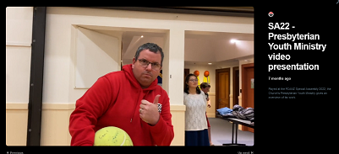
Presbyterian Youth Ministry Video
Originally prepared for GA21 but still current, Commissioners and Observers were treated after an afternoon of business to a video presentation on the work of the Presbyterian Youth Ministry (PYM). The video is also available on the Church Vimeo channel so please share it with your parish - watch of share it here.

Thursday 28 April

Assembly Devotions

Moderator Right Rev Hamish Galloway has invited Katerina Solomona and Rev Dr Selwyn Yeoman to deliver morning devotions to the Assembly. Katerina delivered the 9am Thursday morning devotion, read more about Katerina below. (Note: we will add video of the devotion if/when available).
Katerina Solomona
Katerina is the Deputy Convener of the Church’s Council of Assembly. She has a Bachelor of Arts degree in Education and Maori Studies, as well as a Post Graduate Diploma in Counselling Theory from the University of Auckland.
She has worked in Local Government for 26 years in the areas of governance, policies and strategy before taking up a role at Central Government, Kāinga Ora – Homes and Communities, as the Quality Assurance Manager, specialising in the Building Act and Regulations
Katerina is passionate about mentoring and championing change, focusing on people and continuous improvement in keeping things simple
She is from the beautiful islands of Samoa and Rotuma.

CWS Report
Following the departure of the former national director of Christian World Service (CWS) Pauline McKay, new director, Murray Overton, brought the report Pauline prepared to the Assembly. Liz Whitehead was also associated with the report.
Murray, who joined CWS last August, has a background in education. He has taught overseas in Bangladesh and Addis Ababa, Ethiopia, as well as 20 years as a school principal. He and his wife are in the process of becoming members of St Mark's Church in Avonhead, Christchurch.
Christmas 2020 marked 75 years since the first CWS appeal in New Zealand, providing three generations with access to food, warmth, shelter and justice. Recent issues the CWS has tackled include gender justice, climate action and modern slavery.
Covid has been the biggest challenge the CWS has faced in the last two years. Local organisations concentrated on protecting their communities from infection and hunger but the pandemic revealed the vulnerability of the poorest people in terms of health care, food and hygiene supplies.
Overseas, Sri Lanka, with a chaotic government response to the pandemic, reported an increase in violence to women as well as rising unemployment. Strict government measures such as curfews in Uganda and South Sudan have resulted in low case numbers and deaths though this may also be a reflection of a lack of testing.
Closer to home in the Pacific, the impact has been economic. Unemployment has risen sharply in countries dependent on tourism such as Fiji.
The CWS launched the Coronavirus Emergency Appeal assisting families in Haiti, India, Palestine, Sri Lanka and Uganda with food, hygiene items and health education in 2020. In 2021 it was part of an international effort in India to ensure everyone had access to vaccination.
In the last two years CWS has concentrated on growing their donor base and increasing income. Thanks to their ethical giving programme welcoming new donors, their income has increased by 192%. As well, four seasonal appeals have come in on, or over, budget.
Operation Refugee stalled during Covid but new events and an extended time frame proved popular. CWS recognised the need to assist refugees in Ukraine, the Middle East and Afghanistan.
The CWS board is committed to fostering a greater involvement with Maori and Pasifika churches over the next three years and has begun by increasing the ethnic diversity of its membership.
Assembly endorses Big Hearts Connected World Campaign
The Assembly endorsed the recommendations of the Big Hearts Connected World Campaign. CWS is one of the lead agencies for this campaign launched in 2020.
The campaign asked for:
- A 20% boost to the overseas aid budget
- A doubling of finance for climate action overseas from new and additional sources
- A timeline for getting aid spending to 0.7% of gross national income by 2030.
The New Zealand government is currently a long way from that goal at 0.27%, 18th out of 29 OECD countries. From 2018-21 the government spent only $1 out of every $100 on overseas aid.
Murray noted our Pacific neighbours especially require our support to fight poverty and build carbon neutral economics. As well Covid is undermining decades of progress to end global poverty and discrimination. He said the CWS believes now is not the time to lose focus on helping those in need overseas.

A Rocha presents Eco Church

Assembly saw a video presentation today from A Rocha on their Eco Church NZ project. Their goal is to support churches across Aotearoa New Zealand to actively care for God’s earth as an integral part of their mission. See the Eco Church website. Watch the video here. A Rocha Aotearoa NZ is a Christian environmental conservation organisation.

Special Assembly Keynote Speaker

Adapting to the online format, Moderator Right Rev Hamish Galloway engaged in a Q and A with Special Assembly keynote speaker James Beck today which was played to the Assembly. We hope to be able to share this video with you. Until then, here’s a little about James...
James Beck has most recently worked as the content director at the Parenting Place. Before that he worked for Attitude and was the manager of the team of lively presenters. With passion and his quirky sense of humour, he has delivered presentations to over 200,000 people nationwide, helping them make better choices around drugs and alcohol, sex, depression, youth suicide, technology, social media and getting on with their family.

TELT reports on long and often arduous process
The theological education and leadership training (TELT) task group has been through a long and arduous process to submitting its report.
This was acknowledged at today’s presentation, introduced by Moderator Right Rev Hamish Galloway. “I’m inspired by your persistence and resilience in what has been a long, arduous process,” he said.
Task group Convenor Rev Simon McLeay agreed that they had faced “more than rigorous feedback” in their work to map a new direction for the wider Church in theological education and leadership training.
“Fundamental assumptions needed to change,” he said. “Programmes need to be revisioned from the bottom up to be adaptive to the culture we are called to minister in… People all over the Church are doing what once a minister did. They are less resourced and recognised.”
Sub-Convenor Rev Erin Pendreigh agreed. “There is a chasm between how we resource ministers and everyone else. We have no real national strategy for educating leaders other than ministers in leadership roles… We need fresh eyes on theological education and ministry to be nimble and quicker in how we respond.”
The TELT’s purpose also includes reviewing the place of both Knox Centre for Ministry and Leadership and the Presbyterian Research Centre.
Questions focused on ensuring that a new order of ministry does not inadvertently enhance the very power, privilege and participation issues that have been inherent in theological education.
Rev Dr Stuart Lange made a point that, although he had some concerns about establishing a new order, it has been 481 years since reform was formulated in Geneva and that “change was not unreasonable at this time.”
Commissioners went into dialogue groups before lunch, and Assembly will hear this feedback tomorrow morning, ahead of a vote on a suite of recommendations.
The TELT task group is one of three Council of Assembly taskgroups whose reports were deferred from GA21 to SA22.

Book of Order Amendment reflects a modern reality
Assembly passed an amendment to the Book of Order chapter 5.10. It stated that the presbytery must appoint a Commission to review the future of a congregation, with the option of continuing its mission, renewing life and mission, or if need be, dissolution where a) the total number of adults attending public worship falls below an average of 40 a week for 12 consecutive months and/or b) the presbytery has reason to believe that a congregation is no longer fulfilling the expectations for mission contained in section 2.
Rev Diane Gilliam-Weeks told the Assembly that the current wording is regarded as unworkable and is largely ignored by smaller presbyteries.
Diane said a less prescriptive amendment was required to reflect the modern reality of smaller viable congregations. This would also reflect new expressions of church which often begin with fewer than 40 worshippers.
The Book of Order chapter 5.10 was amended to: “5.10 Review of a congregation on the initiative of presbytery: (1) A presbytery may appoint a commission to review the future of a congregation, with the options of continuing its mission, renewing its life and mission, or if need be, dissolution.”

Covid Impacts Nominations to Committees
The Nominating Committee’s role is to make nominations to the General Assembly for appointments and election to the Church’s national committees.
Convener of the Nominating Committee Liz Whitehead moved that Rev Vaione (Pennie) Togiatama-Otto be appointed to the PressGo Committee and that Efaraimo (Efi) Tuatagaloa be appointed to the Book of Advisory Committee. The motion was passed.
Liz noted that during Covid they had struggled to get people to commit to joining committees, hence the low number of nominations today.

Amendment to Terms of Reference of Doctrine Core Group
Discussion on this amendment was suspended yesterday following further investigation into previous decisions. As a result, it was agreed today that Rev Dr Stuart Lange be given leave to amend the motion, “The Doctrine Core Group may bring to the attention of the Church or General Assembly public matters which have significant implications” to “That the terms of reference of the Doctrine Working Group be referred to the Council of Assembly for review and development.”

Supervising ministers for today’s changing contexts
Today saw the Leadership Sub-committee’s report completed, with a range of recommendations passed.
Most of the recommendations focused on the Certificate of Good Standing. To maintain the certificate, and thus remain on the Ministerial Roll, ministers now must every three years obtain a police check and attend mandated Church ethics and risk management workshops. They are also required to attend regular professional supervision and provide the presbytery annually with an attendance report from their supervisor.
For a provisional certificate to remain valid, presbyteries must monitor the study schedules for new or incoming ministers and sign these off annually as progressing or completed.
Co-convenor Rev Ryhan Prasad said there had been a lot of transitional changes in both KCML and Sub-committee leadership, and heavy workloads. On the positive side, he singled out the Listening Exercise undertaken during 2019, with the aim of providing support to presbyteries when and how it is needed.
“We wanted to be proactive in addressing resourcing issues,” he explains. “We also found that when we talk early and often with presbyteries we get a lot of good traction.”
Some questions were raised by Commissioners about the need for professional supervision and for monitoring.
“We’re in an era of transparency and accountability,” replied Ryhan, “and we’ve seen instances of not enough follow up with ministers on training requirements.”
Amended requirements for ministers of other denominations to be received onto the roll were also approved:
Eligibility criteria has been expanded to include those holding a religious worker work visa.
A 12-month membership of a Presbyterian congregation has been replaced with an approved induction programme.
On a different matter, Local Ministry Team has been renamed Local Shared Ministry (LSM), to align the Church with the nomenclature of the Anglican and Methodist churches. Special Assembly approved establishment and appointment processes for the new LSM team, and the appointment of trained enablers to support the ministry. There was some discussion about the use of the word team, which is not part of the new title, but no changes were made.
In the Book of Order, chapters 9 and 10 will be amended to give effect to the changes proposed in the Leadership Sub-committee’s report. In Defined Terms, the definition for supervision has now been amended by deleting the words “collegial and or.” This last was to ensure that no-one is supervising a person they are in a working relationship with.

Assembly Recognises Climate Action Required
The importance of acting on reducing emissions to limit climate change was reflected in the overwhelming support given to the recommendations put to Assembly by Rev Dr Jordan Redding.
The evidence for climate change was set out in the last IPCC report. The Uniting Church in Australia has adopted a National Climate Actions Plan from which New Zealand can learn and adapt to our situation.
Assembly supported the recommendations that the Council of Assembly:
a) Establish a working group for an initial period of six years to:
i) promote initiatives to help the various part of the Presbyterian Church reduce carbon emissions by 5% per annum
ii) report to the General Assembly regarding how the Church is progressing in reducing carbon emissions
iii) in due course recommend to the General Assembly steps that could be taken to further the objective beyond the six years.
b) Adopt a framework to monitor carbon emissions of Assembly operations, make best endeavours to reduce carbon emissions of Assembly operations by 5% per annum, monitor progress in achieving that objective and report progress to each General Assembly until 2030, taking advice from the work group if it is deemed helpful.

Church to consider additional support for PresCare and PSNZ
Assembly has asked the Council of Assembly to consider lifting its support, in the next budget round, for the Church’s annual contributions to PresCare.
Over the years the Church has supported the work of PresCare and NZCCSS with an annual $15,000 contribution, with PSNZ paying any additional costs. PSNZ asked Assembly to consider inflation, rising costs of membership, advocacy and community outreach when determining the Church’s contribution in the future.
Through meetings with Prescare, PSNZ is aware of the varying capabilities of engaging with presbyteries. They endorsed Presbyterian Support Northern’s Agreement with Northern Presbytery’s Mission Enabler and sought the support of the Assembly to endorse this as a progressive method of engagement. Other regions had found it difficult to engage.
The Assembly passed the motion, “that presbyteries be encouraged to find consistency of method of engagement with Presbyterian Support, that can enable and motivate presbyteries and congregations to initiate more joint activities in the interest of the community we serve”.
PSNZ Report
Chair of the national council of PSNZ, Andrew Johnston, highlighted the various PSNZ bodies working in the community in his report to the Assembly.
Presbyterian Support New Zealand is one of New Zealand’s longest standing and largest community-based social service organisations with seven regional bodies delivering services out of more than 50 offices and almost 200 schools.
Enliven works with older people, providing residential care and retirement village support in four regions. Their Homeshare teams work closely with Dementia New Zealand and DHBs to identify older people with dementia or the beginnings of dementia who may require support.
Family Works assists whanau and young people in crisis, such as those involved with Oranga Tamariki. It provides counselling, social work and parenting programme support as well as practical assistance to families in need.
PSNZ also helps women to reintegrate back into the community on release from prison.
The Central region has developed a children’s rights framework to ensure children’s voices are heard while other regions provide parenting through separation courses. The Northern region has recently acquired national contracts to deliver family violence related support to Shine and Lifeline. These two services will eventually be integrated so individuals in crisis have a seamless experience getting help. Its Youth Services provides a wrap-around service for young people eligible for the youth payment or young parent programme.
PSNZ also advocates at policy levels. As a member of the New Zealand Council of Christian Social Services (the PCANZ is not a member of NZCCSS but is involved via PSNZ) PSNZ meets with the Prime Minister in the hope of influencing government policy on housing, poverty and income as well as New Zealand’s response to Covid.

PSNZ video presentation
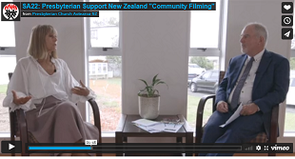
Assembly watched a video today prepared for it by Presbyterian Support NZ and Moderator Rt Rev Hamish Galloway on the work of PSNZ and the Church. Watch the video on the Church's vimeo channel.

PWANZ Continue to Support Women Locally and Internationally
A number of recommendations in support of women were passed by Assembly this afternoon.
PWANZ National President Faaolataga Leasi noted that 90% of the increase in underemployment as a result of Covid was felt by women, who are often the ones bearing the stronger burden of coping with children and working from home.
Presbyterian Women’s work has included promotion of gender equality through work with the National Council of Women, United Nations Association and the International Caucus of the Ministry for Women. They also submitted in support of the Abortion Legislation Bill (now enacted). In 2019, they attended the 63rd Commission on the Status of Women in New York in 2019. They also hosted a parallel event exploring gender equity for older women experiencing both sexism and ageism.
A 2016 Assembly recommendation that a special collection be taken on the Sunday nearest International Women’s Day each March for PWANZ has resulted in generous contributions.
The six recommendations passed today were that:
1. Presbyterian Women Aotearoa New Zealand national and international projects and outreach be supported and actively encouraged within congregations and presbyteries.
2. That opportunities for full participation of women and girls in church courts, committees and other formal groups be actively and intentionally provided.
3. That the Government be urged to take urgent and decisive action to enable all children and their families to enjoy a good life, through eliminating child and family poverty, making healthy housing the norm, and improving food security for children and families.
4. That the World Council of Churches' Thursdays in Black campaign, committing to a world free from violence and rape, be actively supported and promoted throughout the Church.
5. That the disproportionate burden borne by women and girls as a result of human-induced climate change, especially in low-and middle-income countries, including our Pacific neighbours, be recognised and the Government be urged to take strong action to achieve climate justice and effectively care for creation.
6. That the disproportionate impact of the Covid-19 pandemic on women in Aotearoa be recognised by advocating for responses to the pandemic that protect women’s rights and achieve gender equality.

Joined-up decision making proposal deferred to next General Assembly
One of today’s more contentious proposals on connected decision making was referred to Council of Assembly by Commissioners. Proposal 3 was a joint initiative by three presbyteries and sought to address a perceived disconnect across the Church.
The Kaimai, Northern and Pacific presbyteries’ proposal was introduced by Rev Dr Emma Keown of Northern Presbytery.
“There are three main aspects to this,” said Emma. “Presbyteries working in isolation from each other, presbyteries having little or no input into decisions made by the Council of Assembly, and lack of alignment between the National Office work programme and the work carried out by presbyteries.”
Emma also pointed out that recommended changes made by GA 2012 to improve consultation with presbyteries on the business of Assembly and to align their visions had not been implemented.
“General Assembly is not a gathering of presbyteries,” says Emma. “There is still no place for the voice of presbyteries to be heard.”
Today’s recommendations focused on the make-up of Council of Assembly members. They sought to give presbyteries more representation by revising the voting and non-voting membership. Assembly currently appoints all 13 members and the initial response from Book of Order Advisory Committee member Rev Dr Kerry Enright was that the proposed changes to introduce nominees from each of the presbyteries would limit the freedom of Assembly.
Questions revealed considerable uncertainty in the wording about whether the Nominating Committee (and therefore Assembly) or the presbyteries would have the final say on nominees
During the break, a notice of motion was formulated and later put forward by Rev Anne Thomson. It sought to refer the concerns raised with the proposal back to the Council of Assembly for them to engage and collaborate with presbyteries, and report to the next General Assembly.
Rev Rhyan Prasad spoke in favour of the motion, offering feedback from the Listening Exercise carried out by the Leadership Sub-committee in 2019.
“None of the participants wanted more involvement with the Council of Assembly. We need to grow up and do better ourselves at talking with each other. This is not the right tool for the problem.”
Although there were speakers both for and against the motion, the vote in favour was carried by a clear 111 to 33.
Very Rev Richard Dawson, who chaired the debate filling in for Moderator Right Rev Hamish Galloway, thanked everyone for what he said was a “great, considered debate”.

White Ribbon Ambassador Very Rev Ray Coster thanked
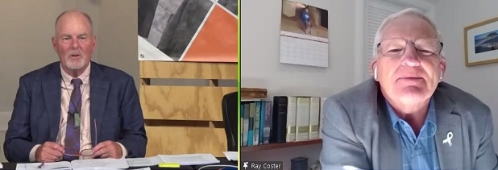
Moderator Right Rev Hamish Galloway invited Very Rev Ray Coster to Zoom into the online Assembly where he was thanked for his work for the Church. Ray has been a White Ribbon NZ Ambassador since 2016 and this year will retire from the role. Hamish also thanked Ray for his ecumenical work. This includes serving on the international World Council of Churches committee, and as Chair of the NZ Board of the International Christian Blind Mission.
Ray expressed the pleasure he has had in serving the Church.

Friday 29 April

Assembly Devotions
Moderator Right Rev Hamish Galloway has invited Katerina Solomona and Rev Dr Selwyn Yeoman to deliver morning devotions to the Special Assembly. Selwyn delivered the 9am Friday morning devotion, we hope to share video of this. Read more about Selwyn below.
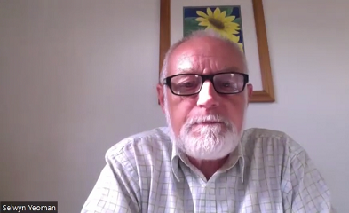
Rev Dr Selwyn Yeoman
Selwyn has been a minister of the Presbyterian Church of Aotearoa New Zealand since 1979. He has served in three parishes – two with strongly rural interests. In 2005, he worked in conservation and community development in Tibetan China. From 2012 -2014 he was Master of Knox College. He concluded his formal ministry working with the inner-city Dunedin Church of Christ Community (where the only space for vegetation was in the spouting…, which caused flooding during rainstorms!). This was followed by a year with Otago University chaplaincy.
Selwyn has been thinking about how human beings relate to the rest of the natural world since childhood - when the wild gully below his house was invaded by bulldozers for a building project – some of which was the work of his architect father.
He has written on, and addressed conferences on, environmental themes. He heads up the Dunedin branch of the international Christian conservation movement, A Rocha. In 2012, he received a Doctorate for an exploration of the idea of human dominion over creation.

Presbyterian Children and Families Ministry video
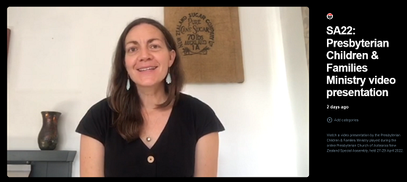
Assembly was treated to a break in business for a video presentation on the work of the Presbyterian Children and Families Ministry. The video is also available on the Church Vimeo channel so please share it with your parish - watch or share it here.

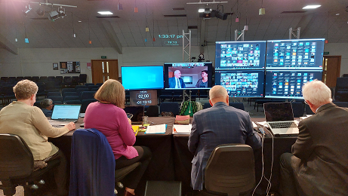
As we go into the afternoon session on the last day of the Special Assembly the 'top table' continues to adapt well to working electronically. Here they face the screens of Commissioners, as a video plays of our churches' ministry in a time of Covid (see it below). Pictured from right to left: Rev Alistair McBride, Assembly Business Work Group; Assembly Moderator Right Rev Hamish Galloway; Heather McKenzie, Acting Clerk of the Assembly; Rev Shona Bettany, Deputy Clerk of the Assembly.

Our churches' ministry in a time of Covid
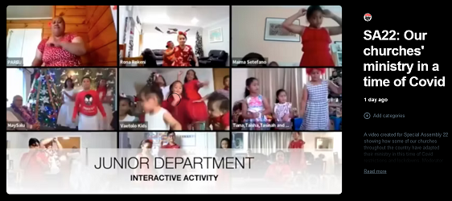
After a short lunch break, Commissioners returned for a video created for Special Assembly showing how some of our churches throughout the country have adapted their ministry in this time of Covid restrictions and lockdowns. Moderator Rt Rev Hamish Galloway asked the churches featured two questions: What have we learnt? How will that shape our future? Watch the video here.

Presbyterian Church Schools video
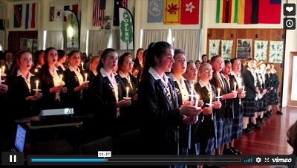
Watch a video presentation on the work of Presbyterian Church Schools. The video is also available on the Church Vimeo channel so please share it with your parish - watch or share it here.

Much debate as TELT given weighty consideration
Commissioners regrouped for an all-morning session on the Theological Education and Leadership Training (TELT) report. It began with the combined feedback from yesterday’s dialogue groups. This was followed by debate and voting on a range of recommendations and amendments/new motions
The feedback was presented by Rev Anne Stewart. Themes that emerged were an appreciation for the KCML and Research Centre staff, concerns which included the costs of implementation, that different classes of ministers would be created, that the proposals may negate the contribution of parishes, and that Te Aka Puaho and the Pacific Presbytery are already overstretched.
There was strong agreement by groups with half the recommendations. The following were voted on and carried without debate:
1. That the partnerships with Te Aka Puaho and the Synod of Otago and Southland, in providing training for ministry and leadership, be affirmed.
2. That the principle of all leaders and ministers in the Church being life-long learners, be affirmed.
3. That presbyteries be invited to encourage ministers, before they take up a new position, to develop a professional development plan.
4. That the Church express its appreciation for the initiatives undertaken by the Presbyterian Research Centre in developing their online presence and collaborating and connecting to further align their resourcing with the needs of ministers and the wider Church.
A proposal brought by Rev Dr Jordan Redding for a statement on the theology of ordination was also carried with little dissent. It asks the Doctrine Core Group to prepare a statement for the next General Assembly that updates the theology of ordination of the PCANZ, including a theology of baptism as it relates to ordination, and that any proposals to develop a new order in the Church be considered after the Assembly accepts an updated statement.
Jordan also introduced an amendment to motion 37 seeking a new task group to implement a plan addressing training needs. He felt strongly that the current wording was too vague.
“This uncertainty must stop,” Jordan said. “There needs to be job security for our KCML staff who’ve been working under a cloud of review since 2017. We need to implement a plan that addresses the TELT report issues. We don’t need a restructure; we need to resource what we already have. Let’s form a task group to get the mahi done.”
Young Commissioners such as Jonathan McLeay and Tom Mepham who spoke against the amendment were agreed that it was further stalling the process “kicking the can down the road” and could bring even more uncertainty.
The amendment was lost. The existing recommendation that proposed a structure rather than a plan for training, one that would create a new Head of Training broader than KCML, was also lost. However, a new motion 72 was carried, that the work of the Knox Centre of Ministry and Leadership (KCML) be affirmed.
The next recommendation was also amended to be a more general statement about “adequate resourcing” for KCML rather than specific FTEs.
Ahead of the vote, Convenor of the Resource Sub-committee Craig Donaldson gave an overview of the financial implications of increasing FTEs. KCML’s current annual costs are $900,000, he said. An increase could add at least another 10 percent just as a baseline, not to mention incidentals adding another 20 percent. Overall, legal and financial reporting costs are also on the increase. Increased costs would be faced disproportionately by parishes due to accounting standards. The Church cannot change cost consolidation, as that would risk loss of charitable status.
A further amendment was made this morning to internships, with the result that Commissioners have adopted the principle of fully funding internships without the need for parish contribution. Consideration will also be given to developing new ministry pathway options as set out in the body of the TELT report. The Council will find a way to progress this intention.
Moderator Right Rev Hamish Galloway concluded the morning session recognising that three years had gone into a report on what were complicated matters, but ones that needed to be addressed. “We’ve got strong opinions about this stuff that stirs up conversation and inevitably the right decisions get made,” he affirmed.
For more background on the TELT task group and its role, see yesterday’s news coverage of the TELT debate here.

Finding A Way Forward on Inclusivity Issues
Yesterday the Assembly carried recommendations on issues of inclusivity in the Church.
The Church has had divisive debates on inclusivity issues since 1985. The winner/loser nature of the debates have caused hurt and anger. Many lament the fact that it detracts from other issues. Nevertheless, the issues remain and are still divisive.
Churches around the world have dealt with the issue by either accepting those in same sex relationships into positions of leadership or recognising that the different positions cannot be reconciled and choosing to separate.
The Presbyterian Church Aotearoa New Zealand can learn from what is happening elsewhere and seek to avoid acrimonious schisms involving property disputes and court cases.
The Pacific churches were especially concerned at what this dialogue would look like in practice since same sex relationships were a sensitive issue in their community.
Lorna Clarke of Presbytery Central said people come to the Church to hear the word of Christ and that they cannot be making up their own rules.
But others spoke in favour of the motion and one noted that queer people were not represented in this dialogue.
Christine Spall responded to Pacific concerns by assuring them that dialogue groups would seek all points of view and thus the Pacific community would have ample opportunity to have their say.
“We cannot keep treating LGBTQI worshippers as second-class citizens. Injustice cannot be swept under the carpet,” she said
The recommendations that were carried are:
The Church commits to a dialogue on a way forward in a Church divided over issues of sexuality, biblical morality and leadership.
That this dialogue be led by the Moderator and Moderator Designate who will gather a group together representing a variety of views on this issue.
That the outcomes of the discussions be reported to the 2023 General Assembly for consideration.
The proposal came from the original brought for last year's Assembly had input from the Presbytery Central Nukuhau Tapu and from Affirm came to an agreed position that a dialogue process would be the appropriate way forward.

God’s mission at the heart of Church property
Rev Dr Ron Mills presented to Commissioners a report of the Theology of Property and Money task group on behalf of Convenor Jenny Flett and member Teresa Parsons.
The report was introduced on Thursday, ahead of dialogue groups. Feedback and voting took place this afternoon.
The group was set up by GA18 and entrusted with two tasks, 1) to develop a theology of money and property, 2) to make recommendations for sharing resources.
The report sets out a theological statement embedded in the principles of kaitiakitanga or stewardship. Commissioners were asked to approve a recommendation that the statement be noted as the foundation for any framework for sharing money and property in the Church. Following task group concerns about a lack of definition for ‘theological statement’ and failed attempts to amend the recommendation, the motion was lost.
Results of the second task drew much initial discussion. “These are what most excited and disturbed Commissioners,” said Ron, as he introduced the proposed changes.
“The Book of Order is silent when it comes to congregations sharing their property with others. There is presently no way to compel congregations or presbyteries to share their property more widely in the absence of the will to do so. The gates to a wider sharing are firmly closed.”
Commissioners expressed in focus groups the view that there is strong attachment to property and financial resources, and a reluctance to prop up failing congregations
Despite that, Ron responded, the Church’s ultimate calling is a generous one. The report’s recommendations embed that generosity. Presbyteries are requested to include a summary of their sharing of resources in their report to General Assembly, and are encouraged to more fully utilise the current framework for sharing resources, as set out in the task group’s report.
A motion to set up a new task group to develop a gracious covenant for sharing was lost, with debate focused on the view that such generosity was already happening, and that relationship building was the key to sharing resources, not a directive from the Council. Rev Colin Gordon also emphasised that the Church has yet to address Treaty issues, which should happen first.
A question raised on Thursday about decolonising the wealth of the PCANZ drew the comment from Teresa that property was bought through a settler model and these inherited structures may not be relevant to today’s context, giving an opportunity to look at and revise the underlying story of property.
The question of decolonisation was grappled with by one dialogue group, and during today’s debate Te Aka Puaho Moderator Marina Rakuraku was asked for her view. Marina said the first step was to find out how the land came to be owned and how resources may be shared. She also said that if the land was gifted by tangata whenua then it should be gifted back.
The Church’s considerable collective wealth is largely held in trusteeships that were formed in the context of colonialism and the Presbyterian Church Property Act 1885. Focus groups reflected confusion about the Act. A new task group will investigate amending or replacing the Act to further encourage sharing, and will review the Book of Order, in particular chapter 16, and report with recommendations to the next General Assembly.

Church Property and the Principles of Te Tiriti
Having committed to supporting the principles of the Treaty of Waitangi, the Church is now considering how to responsibly and ethically deal with the sale of Church land.
Rev Ryhan Prasad spoke to the proposal that those bodies responsible for the sale of Church-owned land and/or buildings offer these assets to relevant Maori entities before the asset goes on to the open market.
The New Zealand Government has settled many Treaty claims with iwi that include land and/or a right of first refusal to purchase various land blocks as part of the settlement.
The Church owns a significant amount of land. Each year a small number of these titles come up for sale. By offering Maori the right of first refusal to purchase land surplus to Church needs, this is one way the Church can honour its Treaty commitments. Maori entities such as iwi or hapu often have easily defined roles and thus it is seen as a quick and easy procedure to contact the correct entities.
After being asked if Te Aka Puaho’s wished to respond, Moderator Marina Rakuraku told the Assembly to differentiate between land that had been gifted and land that had been sold. Gifted land ought to be returned as a gift. Land that was sold can go through a sales process.
Questions were asked about how a price is decided. Should the land be offered at market rates with the first right of purchase offered to Maori? Ryhan responded to this by saying he did not want to make the proposal too prescriptive. People may wish to offer land at a market rate or even below market rate.
He acknowledged this would take more work from presbyteries but said if there’s a chance we can sell land to local iwi or hapu then that is worth the extra work. He noted this was a tangible way in which we can honour the Treaty.
The vote was carried 121 to 12

Support for Eco Church
Today the Assembly supported by a clear majority the proposal that the Presbyterian Church become a denominational partner of Eco Church NZ and that individual presbyteries and parishes be encouraged to join Eco Church.
Eco Church NZ was launched in 2020 by A Rocha Aotearoa New Zealand as a network and resource centre for churches engaged with caring for creation. It began in the United Kingdom and is thriving in many parts of the world. Locally, several Anglican dioceses have already taken this step.
Rev Dr Jordan Redding who brought the proposal said the Church has an essential role to play in responding to the climate crisis and that it should be part of our kaupapa.
Eco Church is free to register. All that is required is a statement of intent. Redding said among the benefits of joining was a self-review process for mission planning, a subsidised programme for zero waste, networking events and resources for engaging with children and youth on ecology and biodiversity projects.
Rev Sharon Ross Ensor supported the motion. Her church has already applied to become part of Eco Church. She liked the fact that it was not prescriptive, other than a commitment to care for God’s earth and provide a story a year about what they had done in the past 12 months. She believed Eco Church would extend and challenge her presbytery.
Jonathan Sunderland questioned the motivation for joining. Was it genuine concern or a desire to appear concerned? Would the enthusiasm last after the initial excitement? He also raised the cost of environmental pursuits which he said were often resource heavy and questioned whether this work was a distraction from worshipping the creator.
Ola Leasi, who seconded the motion enthusiastically, said she was acutely aware of the impact of climate change on Pacific people
Ever since the last Assembly when a proposal called “A Commitment to Responsible Stewardship of God’s Creation” was warmly affirmed, Churches have been having casual conversations, often via Zoom, about what more they can do to address this issue.
They recognise that environmental issues are impacting the Church locally and globally.
Rural and urban communities are preparing for climate-related disasters and seeking to become more resilient and sustainable. In practice this may mean growing food locally or finding creative ways of recycling. Instead of seeing this as outside their purview, the assembly was asked to consider this work as part of congregation mission planning.

EcoChurch Survey and Action commended to Church ministries
The ICBC report was presented to Assembly this afternoon by its Co-chair Joy McIntosh.
She presented an overview of the groups work, noted that they require help to recruit new Church members, and said that the urgency of the pandemic meant key work on climate change was set aside but hoped they can return to this priority in the near future.
A Rocha, the Christian environmental organsiation, has developed an “EcoChurch” survey (www.ecochurch.org.nz/self-assessment-worksheet) and Assembly was asked to pass a motion that all ministry units within the Presbyterian Church undertake the survey and choose one action point from each suggested area to complete over the coming year. The suggested areas are: worship and teaching, church buildings, church land, community engagement and sustainable living.
Joy suggested selecting an issue that suited your church. That could mean aiming for zero waste or looking at what it means for the children’s church.
The report was commended by all speakers and the vote carried 124 to 8.

BOO amendment for ministry team resignations
As its last act of business today Assembly supported a proposal that when a minister applies to resign their charge, the presbytery be required to notify any other ministers in the ministry team and to seek their views. The Book of Order Advisory Committee will be asked to draft an amendment to Book of Order 10:23 (5) to include reference to any other ministers when there is a ministry team.
This proposal was brought to the Special Assembly by the Alpine Presbytery having experienced the limitations of the regulations following the resignation of one of their ministers.
Mavis Duncanson from Presbytery Women spoke her concern about developing policy from a single example and wondered if it could be resolved another way rather than becoming a regulatory matter.
Rev Ryhan Prasad asked why this should apply only to ordained ministers. Why not youth workers and others in the team?
Rev Rory Grant said the change acknowledged the reality that more and more parishes are operating in team ministries. This alteration was a simple courtesy accorded to ordained colleagues.

