Rural Network

News

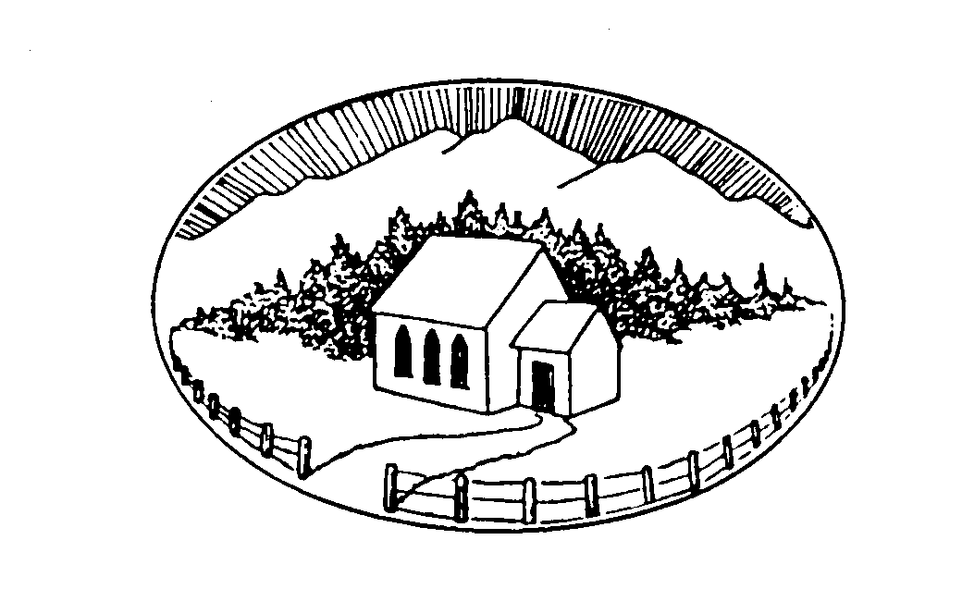

No. 41 March 2010
If we have no peace, it is because we have forgotten that we belong to each other.
Mother Teresa
Rural Network News aims to share ideas for ministry in neighbourhood and land-based communities.
Te manaakitanga, te kaitiakitanga, te kotahitanga.
Please share this newsletter with others you think may be interested. Feel free to make photocopies.
Responses to items always welcome.
Nelson Rural Ministry Forum!
9-11 June
Theme: ‘Community Weaving:
Rural Churches Getting People Together’
The Anglican Diocese of Nelson is organising a Rural Ministry Forum to be held at Tea Pot Valley, Brightwater, on June 9–11 this year.
We are always keen for people from throughout New Zealand to come and join with us as we learn from the guest contributors and from each other.
So bring your team so you can learn and be encouraged. As always there will be great food and fellowship.
If you want to find out more contact: Martin Harrison on (03) 542 3694 rev.harrison@xtra.co.nz or Mark Chamberlain on (03) 548 3124 markc@nelsonanglican.org.nz
rural ministry Seminar in the manawatu
16-18 July
Theme: ‘Grassroots Church’
This is a weekend of workshops and conversations about how the churches in the rural sector, and in small towns, engage with their local communities.
Sponsored by the Knox Centre for Ministry and Leadership, people from all churches are invited.
It will be held at the Rongotea Uniting Church in the Manawatu, from Friday night, 16 July to after lunch, Sunday 18 July.
Cost, including meals and workshop fee: $100.
Accommodation is not provided, but a list of local motels will be available. Limit of 80 places.
Keynote speaker: The Rev Dr Robyn McPhail, immediate Past President of the International Rural Church Association.
Workshops: anyone who would like to present a workshop, please let us know.
All parishes are invited to bring a story to tell about their engagement with their local community.
To register interest and request an application form, contact Brian Pedersen phone 3248232 pedersen.family@clear.net.nz RD6 Palmerston North 4476.
Argument is set by the answers, but conversation by the questions.
International Rural Church Association Conference
20–26 September 2010
At Landjugendakademie,
in Altenkirchen, Germany
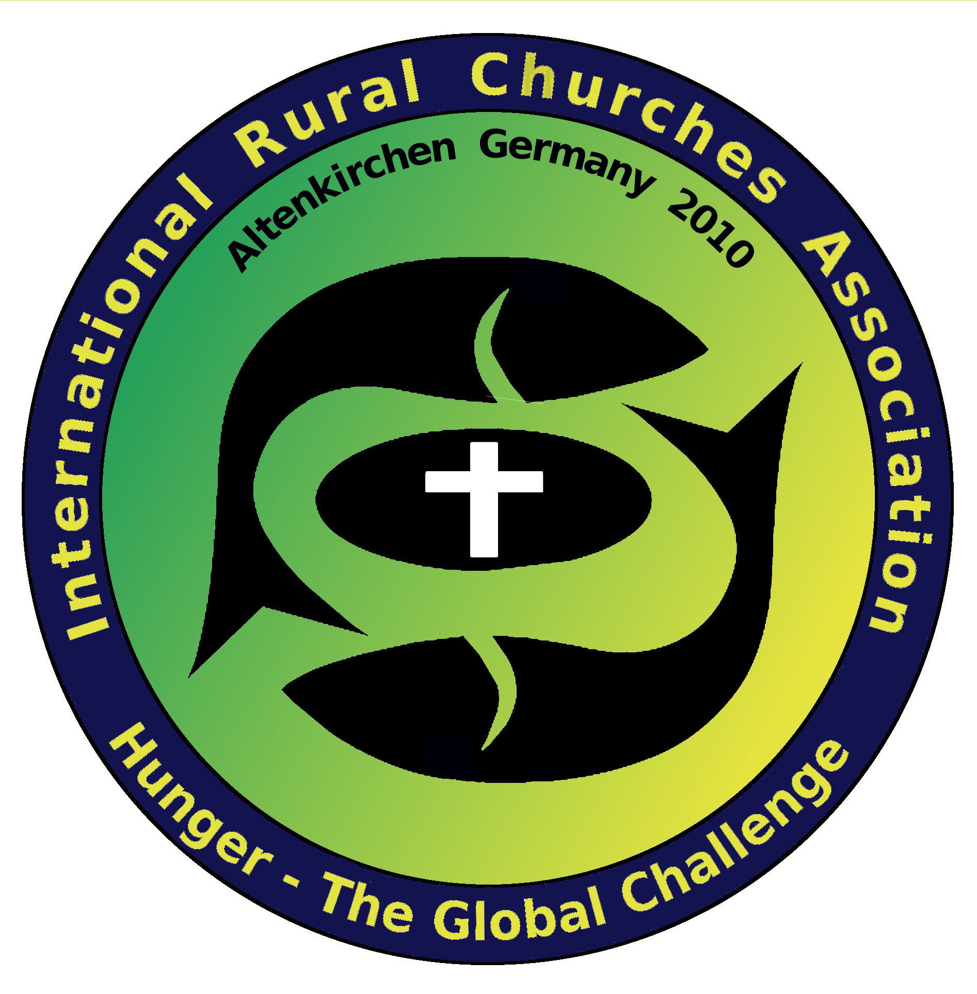
Local Hosts: Churches European Rural Network
THEME: “Hunger – the Global Challenge”
More information on back page
CHRISTMAS JOYS
Christmas at Syde
Many of you will have sung as a carol Christina Rossetti’s poem ‘In the Bleak Midwinter’. For the first time that I can remember it was all actually true. The winter landscape was bleak and snow-covered; ‘earth lay hard as iron, water as a stone’. Yes – this year ‘snow had fallen snow on snow’ and we actually had a White Christmas.
Sue and I live in the tiny Cotswold village of Syde with a total population of 40 and still a largely agricultural settlement. Everyone was involved one way or another in preparing for the Christmas Morning service in our tiny Norman church that seats 25 comfortably in the companionable eighteenth century family box pews.
No electricity, heating decidedly dot and carry, but it’s OUR PLACE (Bishops and Pastoral Committees please note)!
And they came. Despite snow and ice on the surrounding one in six hills, seventy of them came.
Yes seventy. 150% of the total population – is this a record? And I promise you at least half were genuine locals.
As you might imagine we spent the first ten minutes trying to find somewhere for everyone to perch. And then suddenly the local musicians, led by the asthmatic harmonium miraculously played, burst into ‘Joy to the World’ in four-part harmony and we were away. Two couples who were married this year read a four-part dramatised version of the Christmas story. Sadly we weren’t able to bring Jessica the donkey because of the icy roads, but there in Syde Church we now watched as Joseph and Mary (two local children) came to Bethlehem along with Victoria the lamb (we’re sheep country in this part of the Cotswolds) and found shelter in the stable (the chancel).
And the time came that Mary should be delivered and she brought forth her first born son (Alex born earlier this year) and laid him in a manger (in front of the altar). Actually Alex is now nine months old so he elected to sit up in the manger – just like with those Renaissance Madonnas that feature on Christmas cards. It was an ‘ahh’ moment, I can tell you.
Karl the midnight-black rabbit illustrated the wonderful Christmas story of how the silver-spangled black got his fur (my copyright but available on request) as a prelude to some pretty powerful stuff about the way God offers us riches but stored in secret places (Isaiah 45:3).
The intercessions were prepared and led by a thirteen year old and were perhaps the most striking I have ever heard at a Christmas service.
So all in all it was just electric in Syde Church this Christmas morning; with its culmination as we made our own pilgrimage to the Bethlehem altar to receive from him the riches he offers – his Body and Blood.
The choir rounded it all off with the Gloucestershire Wassail, and once we’d got a hang of the tune we all joined in.
And so we went out into the world with a smile on our faces and a sense that this year we really had touched something of the joy of Christmas.
Reports of the death of the rural church in England are perhaps exaggerated!
Andrew Bowden, Syde, England
There is only one way to wisdom: awe. Forfeit your sense of awe, let your conceit diminish your ability to revere, and the universe becomes a marketplace for you. The loss of awe is the great block to insight.... The greatest insights happen to us in moments of awe.
Abraham Joshua Heschel
Christmas in Outback Queensland
The four wheel drive came to a screaming halt in a cloud of dust as she leapt from the cabin and took some steps towards the gidyea scrub before her. “Jack!!” she yelled through cupped hands. “Jack!!”
Being a mother, her voice could easily be heard down the paddock.
Jack quickly hitched the horse he was leading to a post and called back “Yeah mum....what?!?!”
“You’re needed at the church, right now!!”
“What??!!”
“You’re needed to play drums for the Christmas Carols!!”
Now Jack’s a good lad and so he grabbed the horse and started back home across the paddock. He barely had enough time to release the horse into the house yard when he was literally scooped into the passenger seat as his mother set off back to the church.
It was already twenty minutes after the scheduled start and those gathered in the Cloncurry Church were getting a bit toey and my wife was giving me the ‘let’s get on with it’ look. And so with my son, Mark, on bass guitar, we launched in the Aussie Jingle Bells. We got halfway through when in through the doors came Jack. He bolted up the aisle and planted himself behind the drums and without missing a beat, he joined in with us. What a kid!! It really was a ‘only in the bush’ kind of moment.
It is a well known fact that I hate Christmas. It’s actually become a bit of a joke... “What...a minister who hates Christmas??”
Now this year something strange happened. As per usual, I had a mob of Christmas Carol services to do, it was stinking hot and every afternoon the clouds rolled in and threatened to storm. From Boulia to Burketown and McKinlay, from Nelia to the ’Curry, most of December was all about ‘Ding Dong, Merrily on High’ and ‘Deck the Sheds with bits of Wattle.’ I approached Christmas with the same trepidation that I had succumbed to in previous years...BAH HUMBUG!!
Every day was a blur of driving, flying, unpacking, setting up, singing, packing up, flying or driving and then preparing to do it again. Writing this now, I can’t believe that I feel as good about it all as I do. So what went right? What made me actually enjoy Christmas this year?
It’s been a bit of a horror year for us. We lost Teresa’s Dad and received the news of Teresa’s brother's cancer and my Dad’s emphysema.
Then there are the ongoing issues with our daughter’s anorexia. And I didn’t fair too well either. I picked up a flu in India that refused to go. This was followed by swine flu and finally a mild case of pneumonia. Then there was the huge wet at the beginning of the year, the flying back and forth with the Nambour crew doing up airstrips, and a general busyness that hallmarked the whole year. Even our two week break was interrupted by a quick trip home for a funeral.
It was a busy and tiring year. So, the last thing I needed was a busy Christmas. Indeed, as November came to a close I was thinking of ways of skipping December altogether. But, then something happened.
I drove two hours to Nelia, set up my gear, rounded up the kids and prepared for my usual ‘warm up for Santa’ Christmas Carol Service.
The kids looked pretty nonplussed about it all, but then one little girl looked up and said, “I’ve never sung Christmas Carols before...this is so much fun. Thank you so much!”
All of a sudden, the realisation, not just of what I was doing, but what Christmas is really all about, dawned on me. Christmas reminds us that in the midst of all our troubles, all our busyness, all of the painfulness of life, God has heard our groans and has promised to be with us and not abandon us to the trials of the world.
Which brings me back to young Jack. Our regular drummer was missing in action (no idea why) and when everything looked like we were gonna have a typical stuff up, he responded to our need and left what he wanted to do, to help us in our hour of need.
I pray that Christmas was a time of miracle and wonder for you and that 2010 will bring new visions, new hope and new challenges.
If you’re ever up in Cloncurry, come fly with us...
Garry Hardingham, Cloncurry, Australia
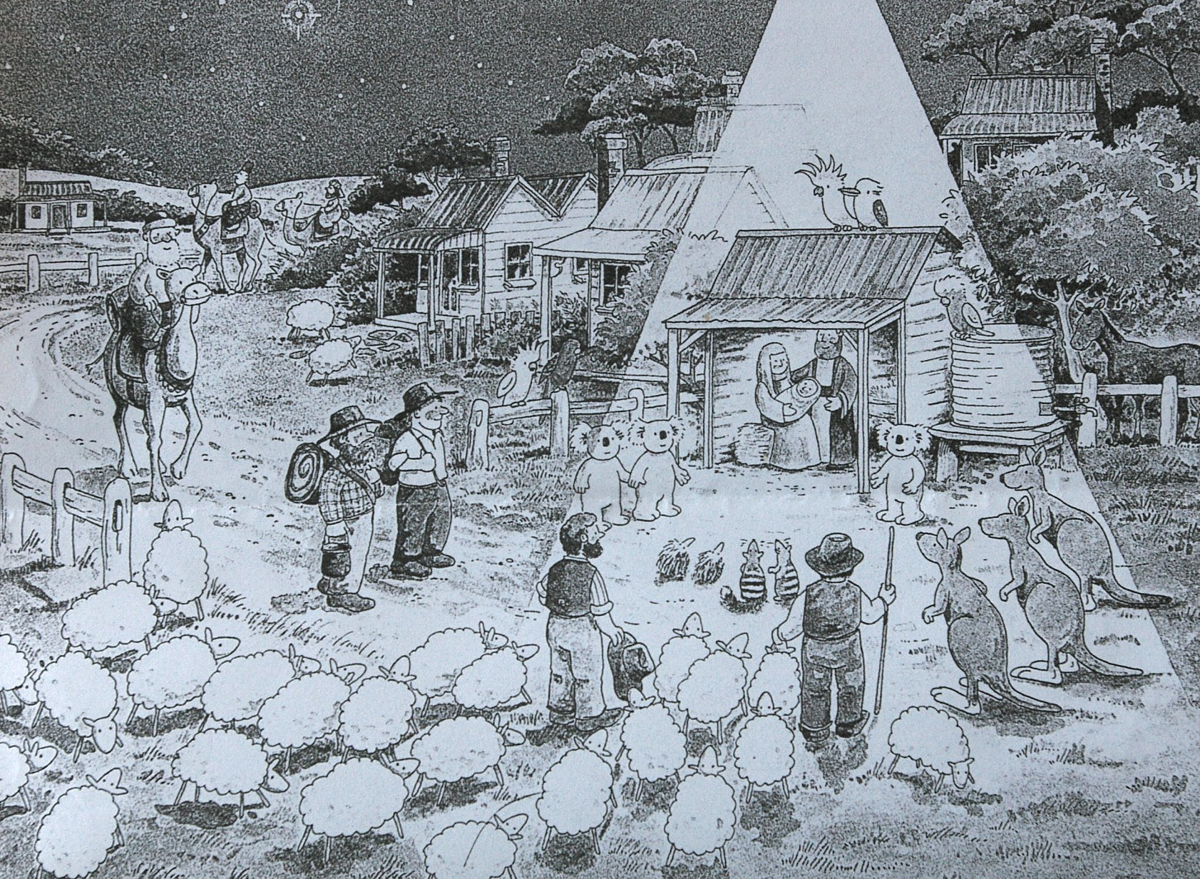
North Hokianga Presbyter’s Christmas
Our oldest son came home for Christmas, arriving with his family of 22 on Christmas Eve later than planned because of the volume of traffic on the roads. We had dinner ready, and had done the preparation for the hāngi to be cooked for midday Christmas Dinner. They ate and then set up their tents and settled in. Our oldest grandson took advantage of the full moon and went eeling down the creek with some of his nephews.
Christmas morning dawned with clear skies, the sound of family waking and the others arriving. It was not long and the hāngi fire was lit and blazing to heat the stones white hot.
I sorted breakfast for my husband, father, auntie and myself, leaving the campers to sort their own. My aunt and I then left the family and headed to Rīpeka Tapu (Holy Cross) Church at Rangi Point, on the shore of the Hokianga Harbour, where we shared the 9am Christmas Service with the local families and with all those who had come home for Christmas.
There were 36 of us from a wide mix of Christian denominations.
Always good to celebrate Christmas in the Lord’s house and Rīpeka Tapu is a very special place, with gentle friendly people, mostly Māori. The building is a traditional church with high pitched roof, dating from the early missionaries. It is not connected to electricity, but has a wonderful wairua (spiritual presence), and colours filtering across the Communion table and the white curtains on the sanctuary rails from the stained glass windows.
After the service we greeted more people as they arrived in Rangi Point for the day and took the opportunity of greeting the relatives.
Gifts of fresh caught fish and produce from the garden and country kitchen were shared, and then we dispersed to our various homes.
Our three bay Vehicle shed which had been cleaned out and set up for cooking and dining was transformed on our return home, decorations were up and tables set in festive ware. More family and friends came to join us and we had a wonderful meal together, blessed by our eldest great grandson. The hāngi was cooked to perfection and we had sea food and salads to compliment it.
Christina Morunga, Broadwood, North Hokianga
STRENGTHENING THE INTERNATIONAL NETWORK
Would you like to help Prasada Rao, from the Church of South India, attend the IRCA Conference in Germany?
A number of rural ministry people met Prasad in 2000 when he attended our Trans-Tasman Rural Ministry Conference in Northland. It was a moving time for Prasad, being in our country and experiencing first-hand the strength and dignity of Māori people and the church at work in a very ecumenical context.
Four years later Prasad led the team that hosted the International Rural Church Association Conference in Chennai that set the tone for conferences since –gathering people from more and more difference regions at about four yearly intervals and meeting in different parts of the world.
Prasad needs financial assistance if he is to be able to attend the Germany conference – around $1,000 would provide for his fares.
He will be a valuable contributor to the conference and help provide continuity of memory and of the spirit of IRCA that it is not a first-world driven organisation, but a movement of equal partners across the world.
If you like to make even a small contribution, please contact Robyn McPhail 09 4017554 or robyn@chirmac.co.nz
Grandma and grandpa were celebrating their fiftieth wedding anniversary. The local reporter came and asked them all kinds of ridiculous questions, such as, “Do you participate in sports?”
“Nope!” said Grandma. “My parents won’t let me.”
“Your parents?”
“Yep. Mother Nature and Father Time.”
From RUMORS email newsletter © Ralph Milton. There’s no charge to subscribe to RUMORS. Send an email message to rumors@joinhands.com with SUBSCRIBE in the subject-line.
EARTH’S FERTILITY
a blessing or a curse?
The film “Avatar” seems at first like a digital extravaganza. But I suspect there are other serious sub-plots – humanity’s hunger to plunder the earth’s resources, the culture and insights of the people of the land in protecting their environment, the economic colonialism that deprives people of their livelihoods. The word avatar comes from Sanskrit and means the manifestation of a deity in human form.
Over Christmas and New Year two other things attracted my attention. By chance I saw a programme on Maori TV about the EU, highly critical of its agricultural policies and its Brussels-based bureaucrats. Farming is heavily subsidised there. We were shown mountains of excess production being poured into landfills. Some farmers received up to 30% in subsidies, with consequent over-production. We were shown an African country capable of producing sugar at a third of the cost of the EU, but unable to find a market because of EU tariffs. So the African cycle of poor profitability and poverty is endemic. This economic policy distortion shows no signs of changing.
I picked up a book written by Professor Tim Gorringe of Exeter University, UK, called Harvest – Food, Farming and the Churches. He is a small farm-holder himself, with an interest in the dynamics of industrial and agricultural production and their effect on peoples and places. He is also a theologian.
The book covers a lot of issues concerning food production, much of it critical of developments globally. For instance, he sees the multi-national food companies governing the way food is produced and distributed.
A farmer friend of mine in Kereru was telling me that the meat company he supplies meat to in turn sells to a big British food chain, and how the accountability line comes right back to his farm. This is nothing new, but it indicates the global dimension of food production. The issue for Gorringe is how this global power both helps and hinders food production. And in the end it is a matter of satisfying the shareholders rather than exercising good husbandry.
He expands on the problems surrounding GE foods and their production and the loss of remaining cultivars and varieties of all sorts of crops and fruits needed for healthy pollination. He explores the confusing area of carbon credits and climate change. I emailed him about his book. He replied and said he already knew of the proposed dairy farm feed-lot system in the MacKenzie country in Otago, and urged caution.
Where I felt he could have expanded more was in the theological area, e.g. how modern food production is set against the great Biblical themes of labour, care for the earth, providing enough food for everyone to survive, allowing nature to rejuvenate itself, and the enjoyment and celebration of food production as something which is God-given – as we try to do at harvest. Perhaps we in New Zealand don’t celebrate enough. Years ago, when I was working in Norfolk, UK, harvest was celebrated in all the schools, and in the church, with great harvest dinners for everyone.
Lent began on 17th February. Somehow the idea of fasting and penitence seems out of place for us in the southern hemisphere, a time when our great harvest is in full flight.
The film “Avatar” is a sign about the dangers of greed. St Paul writes of the whole of creation groaning as humanity tries to sort out it priorities (Rom 8:22). He sees the life, death and resurrection of Jesus as symbolic of God’s dream of society and creation in a new harmony (Col 1:15-20), where all have sufficient. Jesus told the parable of the large scale farmer who delighted in getting bigger and bigger production, only to have his life cut short – an exercise in futility, greed and ultimately self-destruction. (Luke 12:16-21)
When we celebrate our harvest this year we need to keep in mind the complexity of modern global economics and food production, those who prosper and those who suffer through policies of inequality.
Bill Bennett
The book by Tim Gorringe is obtainable from Epworth Books, PO Box 17255, Karori, Wellington 6147, OR sales@epworthbooks.org.nz
If you have come to help me, you are wasting your time. But if you have come because your liberation is bound up with mine, then let us work together.
Lilla Watson, Aboriginal elder
OUR PARISH
Our Parish is Anglican/Presbyterian. We became what we are by an agreement of a memorandum of understanding in 2007 signed by Bishop John Bluck and Presbyterian Moderator Colin English.
The parish had their own understanding of being together from well before my time; and it’s always been said Takapau does it their way. This is something I learned very quickly in the past seventeen years of being in the parish.
Both denominations have worked alongside of each other without becoming a Co-operating or Joint Venture body
Our Parish is basically a rural parish even though we have churches in the communities of Takapau, Ormondville and Norsewood. The congregations are mainly rural parishioners.
Our area boundaries south east of Waipukurau to Matamau, north of Dannevirke and out to the Ruahine Range coming back up to the areas of Ashley, Clinton, and Makeretu.
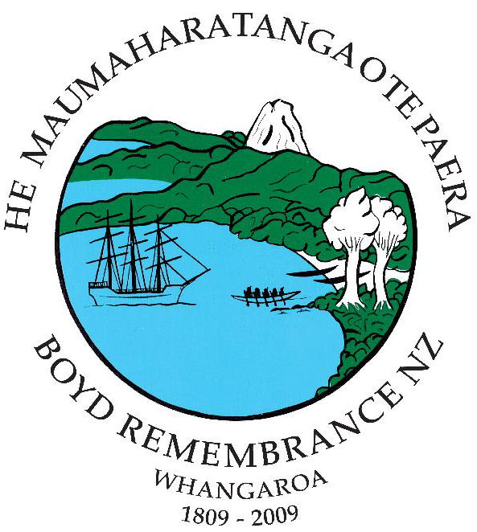
St Mark’s Takapau is Anglican and has a service each Sunday. The Church of the Epiphany, Ormondville, is also Anglican, has one Service a month, and has recently celebrated 125 years. It is a beautiful historic church and had a declining attendance. The community really got together when they found that the church could possibly be relocated to another area for further use. A public meeting was called and since then a congregational committee has been elected who report back to the parish council. Attendances improved, making the 125 year celebrations very successful. These same parishioners have stayed on the committee, are enthusiastic and care greatly for the church in their area.
St David’s is the Presbyterian link at Norsewood and again an historical church building, with a service held on the first Sunday each month by a Presbyterian minister who travels down from Napier and does a service at Takapau before travelling onto Norsewood.
As we move into 2010 we know there will be some changes and challenges ahead.
Our parish is looking to boost children’s ministry and has started the year off in a positive manner with a roster of enthusiastic parents, using a programme designed to encourage and foster children’s understanding of Jesus.
After five years, Mainly Music continues and provides an opportunity for mums of all ages to get together with their babes and pre-schoolers. Community Café is a new initiative undertaken and comes under the umbrella of the Enliven programme, along with Age Concern and the parish pastoral care team. Morning tea, Tai-chi, activities, lunch, and entertainment is enjoyed by those attending.
We like to be creative and have had Garden Services in the Daffodils in the spring and Liturgy in the Lavender in the summer as a parish fundraiser. This year we are planning to hold Harvest Festival in a local vineyard.
The parish is very supportive of the two ordained local priests, who have a parish council of ten members including elders. Our accounting system works very well, in the past there were two separate financial statements each month, now it is one and so much easier to follow.
Our goal is to bring more people of the local communities to become part of the congregation where they cannot only meet their rural neighbours but experience God’s love
Our parish is a very caring mix of Anglicans and Presbyterians worshipping together
Rev Dorothy King, Takapau, Hawkes Bay
BOYD REMEMBRANCE
As a good rural minister (or trying to be), when a couple of the long-term locals of the district asked me to be involved in the planning of a community event, I did as I was bid.
It was to mark 200 years since the burning of the ship the Boyd. The ship had come from Sydney to collect kauri spars on its journey back to England. This was the early years of contact between Europeans and New Zealanders and the balance of Māori well-being had been badly affected. Whatever led to the decision to destroy the ship and kill almost all of those on board is a matter of dispute and the evidence in the public domain incomplete. Pākehā historians have written about it but most of the histories handed down to local Māori have not been heard. The ill-directed reprisal killing of large numbers of a Bay of Islands hāpū only added further to misunderstanding and mistrust. It remains a sensitive matter today.
The Boyd Remembrance happened from 4-6 December 2009. We began with pōwhiri at the local college on Friday. The formal welcome of a pōwhiri is second-nature in the Whangaroa community and on this occasion tikanga was at its most powerful in a deeply moving event.
The first group of visitors recognised were family of Betsey Broughton who was aged two when she survived the sacking of the Boyd (her mother died), many of them from Australia where Betsey had eventually returned and grew up, married Charles Throsby, and had 17 children. The second group were churches, regional and national leaders and a large group from the Presbyterian Māori Synod. The third group were the politicians.
Saturday’s gathering under a large marquee by the Whangaroa harbour began with a salute by three waka and ended with cannon fire following by the peace-bringing sound of the Pūtātara (conch). The formalities following opening karakia included greetings from the local mayor and Northland politicians, and speeches that expressed the real point of our gathering. A descendant of Betsey, a member of an early Pākehā-settler family, a kuia, and a kaumatua told us their stories of the Boyd, of relationships lost and gained. There were more contributions during the hākari – truly a feast –some from home people, others from visitors reflecting on the remembrance event and affirming the insight and courage of taking it on. Wise words too from Sam Sefuiva of the Human Rights Commission. He affirmed steps taken in listening and learning from each other and encouraged us to continue a sustained dialogue to become more and more a community in partnership.
On Sunday an Ecumenical Service by the harbour was a feast of prayer led in turn by number of churches, Māori and Pākehā, and Bahá’í. A month before an ecumenical group had gathered for a Hīkoi Karakia (a journey of blessing) during which we travelled down the harbour and back to bless the key sites of the events of 200 years ago. Wreaths of kawakawa interwoven with wild roses were placed at the harbour mouth, a similar wreath being part of our Remembrance Sunday Service.
For the churches this was an opportunity to express our shared faith in support of our community. Some people were surprised we could work together so well: we were a witness ourselves to the real prospect of reconciliation and partnership.
The event of 200 years ago, and assumptions made about it in the years since, have given pain to our community. A number of people didn’t want the Remembrance event to happen, because they thought it would make the pain worse. Indeed it would have if the purpose had been to pontificate about the event and establish a so-called correct account of what happened.
For that would have made it the Pākehā-driven event that some Māori feared and the digging-at-the-wound event that some Pākehā feared. We chose to do what the word Remembrance reflects, as on ANZAC day, when we remember people involved in wars and tell our own stories of what it has meant to us.
There are many more stories still to be told. Our Remembrance was just a beginning, for this seems to be a first for our community that the space felt safe enough for those deeply affected to tell us what has been handed down through their family. Sustained dialogue means we need to keep working to provide safe places for Māori and Pākehā to listen to one another.
As a member of the organising committee, I experienced first-hand the ongoing task of sustained dialogue. Māori and Pākehā working together, we had to learn to read each other’s body language, gain courage to speak when we might have been silenced, and be silent when we discerned it was not our time to speak. Getting to know one another was in fact the whole point and process of the Boyd Remembrance. It is more a process than an event.
We want our young people today to see the way of trust and partnership as the norm not the exception. A comment often made was that our children should not have to carry the pain and the disputes of the past. Our remembering is the process that makes it possible to let go the raruraru/trouble and gain peace of understanding.
Robyn McPhail, Kaeo-Kerikeri, Northland
Hunger – the Global Challenge
International Rural Church Association Conference
Local Hosts: Churches European Rural Network
20–26 September 2010
Landjugendakademie, in Altenkirchen, Germany
Registrations of interest have come in from Africa, Asia, North America, UK and Europe (including Iceland) as well as from rural ministry stalwarts Australia and New Zealand. It is expensive for us to attend a conference in Europe but it is perhaps the most accessible region for the majority of the world, both in terms of distance and in terms of obtaining a visa to enter. (Also 450 Euro – currently around NZD900 – for a full week’s accommodation and activity in Europe is cheap at the price!)
What this conference offers is the opportunity to spend time with rural church people from a broad range of localities around the world, focussing hearts and minds on Christian mission in relation to today’s big issues of food and water.
Each day of the conference keynote speakers from different parts of the world will cover the global challenge of hunger, migration and hope for the countryside: the churches’ response. A report from the International Assessment of Agricultural Knowledge, Science and Technology for Development, agreed to at an Intergovernmental Plenary Session in Johannesburg, South Africa in April 2008 will be a focus for some of the discussion.
Bible Studies, with presenters from Canada, New Zealand, India and the UK, will take place each day. There will be a field trip on Thursday and scheduled times for group work, with small groups formed at the start of the conference and working together throughout the work. Reports from the regions will feature, with an emphasis on projects that others might build from. By the end of the conference a shared resolution will be formed to take home to participants’ churches and communities.
The programme begins with check in prior to dinner at 6pm on Monday 20 September and ends with breakfast on Sunday 26 September and the possibility of attending worship in the region.
The conference fee of 450 Euro covers registration, accommodation, meals, and field trips.
Go to the IRCA website www.irca.net.nz click on Upcoming Events for information. The link to registration can be found on the home page.
For those flying in and not opting for “Conference Scattered”, the hosts suggest we arrive in Frankfurt on Sunday 19 or Monday 20. A shuttle service to Altenkirchen is included in the 450Euro.
Those who wish to arrive for a Conference Scattered experience – being hosted by a rural household within the region – are invited to fly in to Frankfurt on Thursday 16 September, be shuttled to Altenkirchen and collected from there by their hosts. Participants will be the responsibility of their hosts during this time, including getting them back to Altenkirchen on Monday 20. A culturally appropriate way to respond to this hosting is to bring a gift for the hosts that is something special from one's own region or country (and it would be good that purchasing this gift be something that supports one’s local region).
New Zealanders planning to attend, who would like to share travel plans in case there are opportunities to link up, are invited to get in touch with Janice Purdie janmp41@xtra.co.nz.

This occasional newsletter is printed by Anglican Diocese of Waiapu and distributed by a Hawke’s Bay team.
Contributions of news, views, insights on anything to do with the rural church and its gospel mission gratefully received.
Editor: Robyn McPhail, 17 Campbell Lane, Kerikeri 0230, 09 401 7554, fax: 09 401 7555, email: robyn@chirmac.co.nz
Thanks to all contributors and to Garth Cant for editorial assistance.

