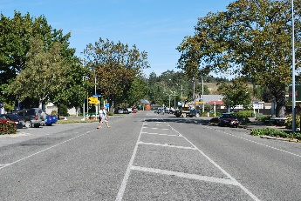
Hawarden Farmland Welcome to Amberley Main Street Cheviot

Combined Hurunui Parishes, North Canterbury

Incorporating the Kowai Parish (centres at Amberley and Cheviot)
and the Waikari Parish based at Hawarden

The Combined Parishes seek a Full-time Minister (based in Amberley),
for an initial period of 5 Years.

The centres of Amberley, Cheviot and Hawarden
support a rural hinterland.

We are seeking a minister who is:

- a preacher who stimulates both thought and action
- a person for whom connection with people (and pastoral care) are essential
- a spiritual leader who empowers members in their ministries
- a person who will be active in building networks in the wider community

Are you the person to help us focus on God’s vision
for our widespread parishes
and to work with us in ministry and service within the communities?

Expressions of Interest to the Rev. Chris Elliot mcelliot22@gmail.com 027 451 5296
A Parish Profile will be available by e-mail.

