Join us, in person or online, for the:
Contentious Presbyterianism Forum

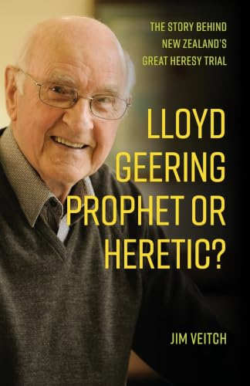

Saturday 29 August, 10 am to 3 pm
Frank Nichol Room, Knox College, Dunedin
Jim Veitch and Niki Francis are keynote speakers, with the Dunedin launch of Jim’s book, Lloyd Geering: Prophet or Heretic? Martin George Holmes, Mark Grimshaw, and Terry Pouono will also be speaking, and Alofa Lale and Yvonne Wilkie will be contributing to the panel discussion. A plattered lunch will be provided. Morning tea starts from 9:15 am. A $10 koha on the day is suggested. Zoom livestreaming will be available for each of the day’s sessions. The Forum is organised and presented by Presbyterian Research Network (PRN), and it is cosponsored and hosted by Presbyterian Research Centre (PRC). For a detailed flyer with talk descriptions or to get Zoom links for the sessions, please contact: jay.robinson@prcknox.org.nz

