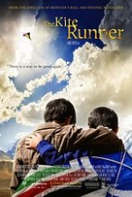
Movies and More

The Kite Runner
“There is a way to be good again.”

The story is about the bond that develops in Afghanistan between a privileged youth and the son of his father's servant, around a love of kite flying. The relationship fractures when one boy is set upon by toughs during a kite-flying tournament and the other boy does nothing to help him. Years later, a reunion amidst the wreckage of the Taliban regime reconnects the youths.

Review Comments by David Bruce from Hollywood Jesus Website.,

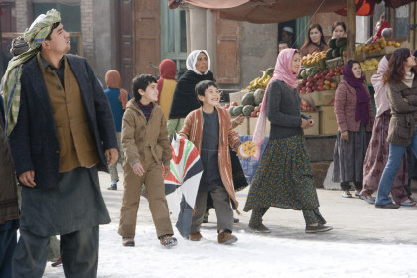
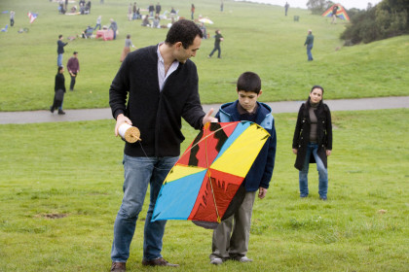
Based on one of the most acclaimed novels in recent memory, THE KITE RUNNER is a profoundly emotional tale of friendship, family, devastating mistakes and redeeming love. In a divided country on the verge of war, two childhood best friends, Amir and Hassan, are about to be torn apart forever. It’s a glorious afternoon in Kabul and the skies are bursting with the exhilarating joy of an innocent kite-fighting tournament. But in the aftermath of the day’s victory, one boy’s fearful act of betrayal will set in motion a catastrophe ... and an epic quest for redemption. Now, after 20 years of living in America, Amir returns to a perilous Afghanistan under the Taliban’s iron-fisted rule to face the dark secrets that still haunt him and take one last daring chance to set things right.
Golden Globe-nominated director Marc Forster (STRANGER THAN FICTION, FINDING NEVERLAND and MONSTER’S BALL) brings to life Khaled Hosseini’s bestseller on the screen with a globally diverse cast and crew, mixing a remarkable group of non-actors from Afghanistan and Central Asia with an accomplished international cast, and shooting on location in the Western Chinese desert bordering Afghanistan. The result is a journey into a new world - through a universal human story that speaks to anyone who has ever yearned for a second chance to make a change and find forgiveness.

Come explore how this movie navigates the range of emotions and causes us to look at ourselves, evaluate our own values and understand that there is a way to be good again.
Questions:
- What is your response to the movie? How did it make you feel?
- What does the movie have as its major message? DO you think it is summed up in the phrase, “There is a way to be good again?”
- What does it say about sacrifice, friendship? How do you interpret it? Was the director successful in communicating these themes?
- What sacrifices are made in the movie?
- Can you identify other key themes in this movie? What are they? Explain.
- The book which this movie was based on is a best seller. It is also used as a text for Year 13’s at many colleges. Why do you think this would be? Do you agree with their choice?
- In many ways this movie is a sermon on friendship? Is it effective? How / Why?
- Like last month’s movie this movie has had an impact on wider culture? What do you think it is?
- What does it show about Afghanistan?
- What does it show about the Taleban? Is it fair?
- Any final comments? What will you take form this movie? What difference will having watched it make for you?

Spiritual Insights:
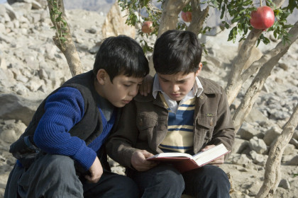
Thankfully, in this flawed and imperfect world, that’s not all that goes on. As perhaps my favourite character in The Kite Runner shows, there are people who know the power that exists in serving others, in loyalty to others, and in seeking a greater good that just their own. Throughout the childhood portion of the movie, Hassan demonstrates this selflessness and loyalty to an extreme. It is inspiring and at the same time painful. Even when Hassan has been horribly wronged through his loyalty to Amir, Hassan still refuses to do any wrong to Amir. You want to tell him stop or he will keep getting hurt. But you also can’t help but see how beautiful his selflessness is amid the ugliness around him. And when Amir is called back years later to provide a rescue from the injustice that still continues, it is as if we are finally seeing Hassan’s loyalty and selflessness come to life in Amir. He may have been too afraid when he was a child, but now he is not. And even though Hassan is no longer able to fight for the good of others, Amir will.
The Kite Runner, for its tragedy, for its beauty, and for its reminder of just how powerful a single act of sacrifice can be against even the most destructive forces of evil, I know it will always be a movie I will remember.

