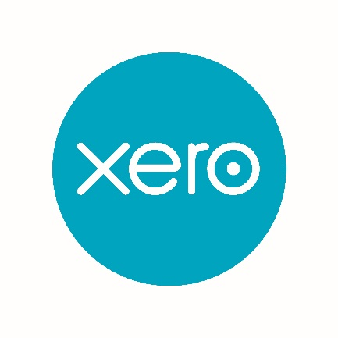
This document will be emailed to each Parish with access to your Xero file so you can use the links to access the Xero Help Centre directly.
Xero Initial Training
This training document is purposefully not going to include lots of text but it is going to include lots of links to the Xero help Centre. The reason for this is that Xero provides free help in the help centre and it is the best we have ever seen! Very rarely can you not find the answer to a Xero question in the help centre. On the rare occasion, you can’t you can email Xero support from the help centre or for a parish specific question email xero@presbyterian.org.nz - we are here to help.
Getting Started
When you first open your Xero file you will see a blue box at the top of the screen (see box below). Click on each of the links (when you have logged into Xero) and watch the short video clips which will give you a good overview of the features and what to do first.
DO NOT SKIP THIS STEP it really will get you going!
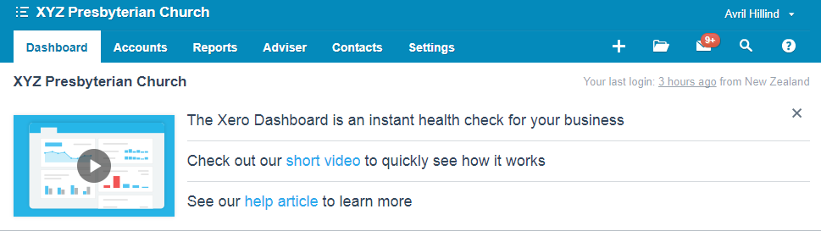
Where ever you see blue text in Xero this means you can click on the words and it will drill down to an explanation or more detail
As part of the Xero set up you will already have
- The Parish Chart of Accounts which drives the report pack for your year end accounts. You can edit the description of any code without affecting the reports but adding new codes will require checking that the correct reporting code is associated with that account code (this will be covered in the annual accounts training document). We suggest that in most cases changing the description of another code in the same area that you don’t need is the best method.
Here is the link if you would like to add or edit codes https://central.xero.com/s/article/Chart-of-accounts-in-Xero

- Bank feeds – A copy of your bank transactions will be dropping into Xero every night ready for you to code.
You will need to set up
- Parish details such as address https://central.xero.com/s/article/Update-your-organisation-s-settings
- Tracking categories – this is optional but if you want to produce separate reports for particular activities such as operation of an Op Shop or an education programme then this is a useful tool https://central.xero.com/s/article/Set-up-tracking-categories
Opening Balances
When we receive your conversion form we will email you about the best way to send us the information we need, we want to make this as easy as possible for you.
If you are converting from another accounting system we will help your do this so this stage should all completed by the time you read this document. If not contact xero@presbyterian.org,nz
If you want to start Xero from the beginning of the financial year (this is the recommended method if you were not using an accounting system previously) then you can
- Import bank statements form the 1 April until the date the bank feeds started https://central.xero.com/s/article/About-manually-importing-bank-statements if your Parish does not have internet banking access then contact us at xero@presbyterian.org.nz and we can help you manually enter the transactions from your bank statements.
Invoicing
To invoice for goods or services provided by the Parish there a few setup matters to attend to before you start. Then follow the instructions to enter invoices.
You will need to enter your Parish details to appear on your customer invoices and upload a logo if required. This is in the settings tab under Invoice settings https://central.xero.com/s/article/Add-edit-or-delete-custom-invoice-quote-templates
Watch the sales overview video https://go.xero.com/Accounts/Receivable/Dashboard/ then the link for entering invoices is here https://central.xero.com/s/article/Invoice-a-customer#Createanewinvoice
Entering Supplier Bills
To enter supplier bills for accounts you are going to pay at a later date (not recurring regular payments) go to the purchases dashboard and enter each bill.
Here is a link for the purchases overview video https://go.xero.com/Accounts/Payable/Dashboard/
The here are the instructions to enter supplier bills https://go.xero.com/Accounts/Payable/Dashboard/
Jump right in
Your ready to reconcile your bank transactions, from the dashboard click the blue reconcile items button and use one of the following methods
- Bank rules https://central.xero.com/s/article/Create-a-bank-rule Use this option as often as you can as this saves lots of time in the following months when a similar transaction comes up again. Suitable for regular monthly payments that you make by direct debit such as power and telephone charges.
- Find a match – this is when you want to apply a receipt to an invoice you have raised or a payment to a supplier invoice for those items paid on the 20th of the following month for example. https://central.xero.com/s/article/Reconcile-a-bank-statement-line-using-Find-Match
- Transfer tab – for transfers between your own bank accounts https://central.xero.com/s/article/Transfer-money-between-your-bank-accounts-in-Xero#Createaquicktransferduringreconciliation
- Create tab https://central.xero.com/s/article/Add-a-spend-or-receive-money-transaction-while-reconciling#Web

Create tab: create a spend or receive money transaction when there is none
If Xero can’t find a match or it doesn't create a suggestion, it will leave the statement line unmatched ready for you to create or find a transaction to match to.

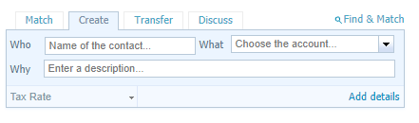
Create a Xero spend or receive money transaction quickly by adding the contact name into the Who box, account (What box) and description (WHY box, this is optional) under the Create tab.
If you enter a name that does not already exist as a contact, Xero will create a new contact.
Select Add Details to enter a full spend or receive money transaction within the bank reconciliation process. Use this when you need to add more lines to code the transaction to more than one place for example membership subscriptions and CBE class fees received in the same deposit.
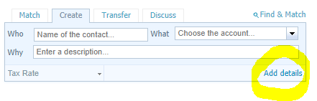
If you need to change the GST tax rate click the drop down box and select the rate you need. All account codes default to the most common tax rate for that code.
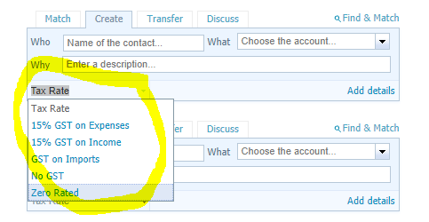
If you want to see the full help on bank reconciliations https://central.xero.com/s/article/Bank-reconciliation-in-Xero
How do I correct a mistake?
Good question, you can drill into a transaction from the account transaction screen within the bank reconciliation https://central.xero.com/s/article/Find-and-view-transactions or from a report and then edit the transaction https://central.xero.com/s/article/Edit-a-spend-or-receive-money-transaction
Fixed Assets
Fixed assets such as equipment that cost over $500 you will want to enter onto the fixed asset schedule as you go during the year. If you had assets at your conversion date we will have entered them as part of the conversion process.
The overview vide is here https://fixedassets.xero.com/?CID=!!VmGS#assets/draft and the detailed instructions are here https://central.xero.com/s/topic/0TO1N0000017kmXWAQ/fixed-assets#business
This topic is also covered in the End of year Annual Accounts training documents
Parish Reporting
Once you have reconciled all your bank transactions and entered all your invoices for the month then you are ready to run reports.
- Reporting in general on Xero
https://central.xero.com/s/topic/0TO1N0000017kmLWAQ/reporting-tracking#business
There are a wide variety of performance, cash, position and detail reports from the all reports menu.
- Parish Reports
We would suggest the two reports in the interim report pack be distributed for each parish meeting. This is the Statement of Financial Performance (Profit and Loss) and Statement of Financial Position (Balance Sheet). If there is a requirement to also see a list of payments for the period the Expenses by Contact Report would be useful.
From the Accounting Tab at the top of the screen select Reports then Advisor and the Report Template called “Interim Report” you can click the star to the left of the title to make it blue which will then show the report on your favourites list. There are a number of reports here that you can use and adapt to your requirements. https://central.xero.com/s/article/About-the-new-reports
When the report opens select the compare periods tab to select the correct time period (or date range box in top right depending on the report) and update. The Statement of Financial Performance (or Profit & Loss as you may be more familiar with) can be run across different time periods, compared to previous periods or budget. Detailed instructions here https://central.xero.com/s/global-search/%40uri#q=profit%20and%20loss%20report
The second tab shows the Statement of Financial Position (or Balance Sheet) can also be run with comparatives to different months, last year or last end of year. https://central.xero.com/s/article/Balance-Sheet-New#Newversion
To enter a Parish budget into Xero please follow the instructions in the Help Centre https://central.xero.com/s/topic/0TO1N0000017kp0WAA/budgets#business
If there is one particular income or expense code which looks unusual for the period and you would like to include the detail of this in the report click on the blue $ value which will open a transaction listing for the period, then click the blue button at the bottom of the page to add it to the report. Alternatively, if you click on the description of the line item it will open a report showing the period balances by month for this account with a line graph showing the trend at the top of the page.
- Annual Accounts
This is the subject of a separate document but you can access the Parish Annual Report Template for Parishes from the Accounting tab under Reports. An example of these reports is in the Xero for Parishes document.

