Fulltime Minister
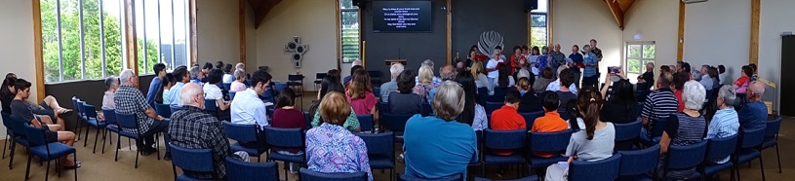
Albany Presbyterian Church is a warm, family friendly and inclusive community who are looking to call a fulltime minister to join us in the next stage of our journey of faith.
Our congregation draws from a wide range of ages, backgrounds and ethnicities that reflect our location in a rapidly growing area, where the Massey University and school campuses sit alongside modern residential and shopping complexes.
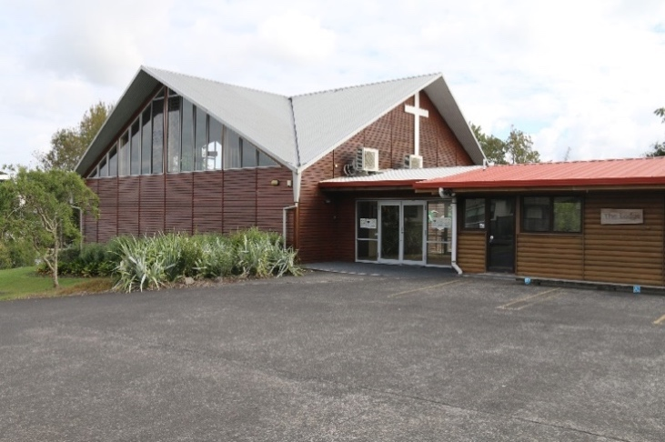
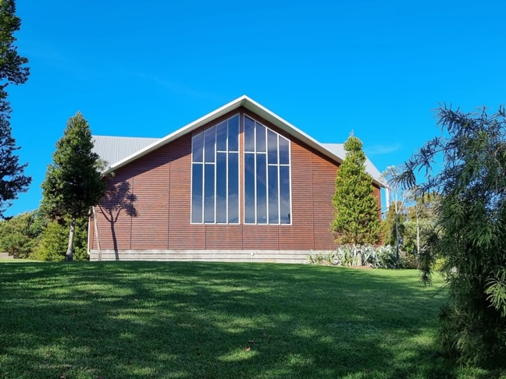
We value thoughtful worship, and a strong thread of contemplative spirituality runs through our community life. You will find us to be a strong, active congregation, hospitable and grace centred.
Our leadership are collaborative and represent a congregation open to new ideas, as we seek to enrich communal life and extend our presence in the Albany community.
If you would like further information on this opportunity, please contact our Convener of the MSB, Rev Werner Schroeder, minister@hbcpc.org.nz, 021956581

