GLENFIELD COMMUNITY CHURCH
0.5 PART TIME NATIONALLY ORDAINED MINISTER
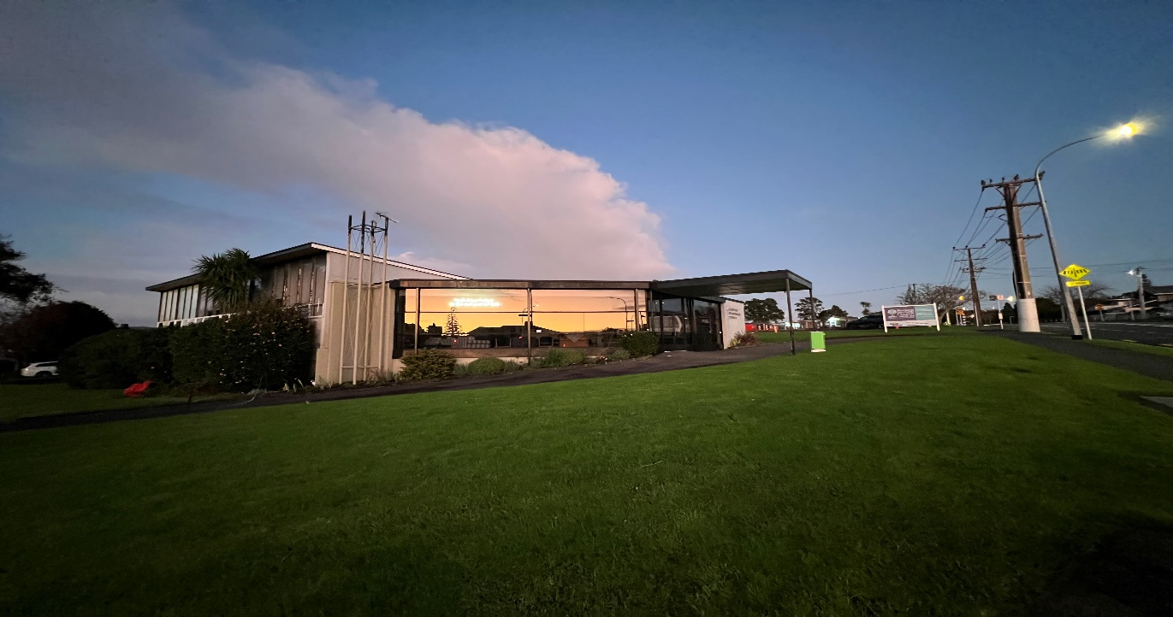
We, at Glenfield Community Church seek to call a 0.5 Nationally Ordained Minister to lead, inspire and work with us in taking the Gospel message to our community.
Our Church is centrally located on Auckland’s North Shore, close to its major shopping areas, beaches, schools and universities. We are a multicultural church, well connected with and serving the community around us. Currently we have two contemporary services, one held in English and the other in Korean , For this reason, we are looking for a minister, with a caring pastoral heart, who can speak in both English and Korean, who will be the spiritual leader of the church. We are looking for someone who is sympathetic with our Vision, Mission and Values (as set out in our Profile) who might introduce us to new initiatives to grow the congregation and meet community needs. Such initiatives could include working closer with other North Shore Presbyterian Churches.
It is proposed that the terms of call be the standard terms of call as contained in the conditions of service manual and appropriate allowances for seniority as provided by the council of assembly but applied as pro-rata in accordance with the part-time nature of the position.
In recognition of this being a part-time call, it is proposed that the preaching and pastoral duties are shared with the eldership and other employees (such as the community pastor and youth pastor) of the Glenfield Community Church who have various degrees of theological training. The final configuration of this will need to be negotiated and agreed upon by the part-time minister and will of course depend on their preferences, gifts strengths and availability
If you would like further information on this opportunity to lead us, please contact the Convenor of the MSB, Ian Watson iandpwatson@xtra.co.nz Phone (09) 4784817 mob.021 352 898 by Wednesday January 31st 2024..

