BACKGROUND
This profile has been prepared as an information source for anyone considering joining our parish in a spiritual mentor role. It attempts to show how our church community functions and supports its members and wider community.
MISSION STATEMENT
To become more Christ like and serve Him in the community
This mission is achieved through the work of the Church, the Paeroa Community Support Trust and includes the employment of a family worker.
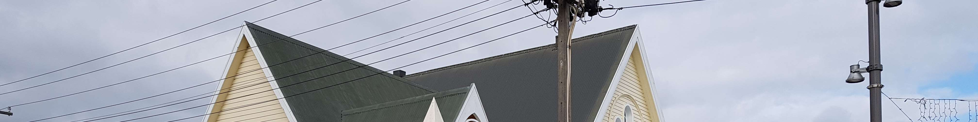
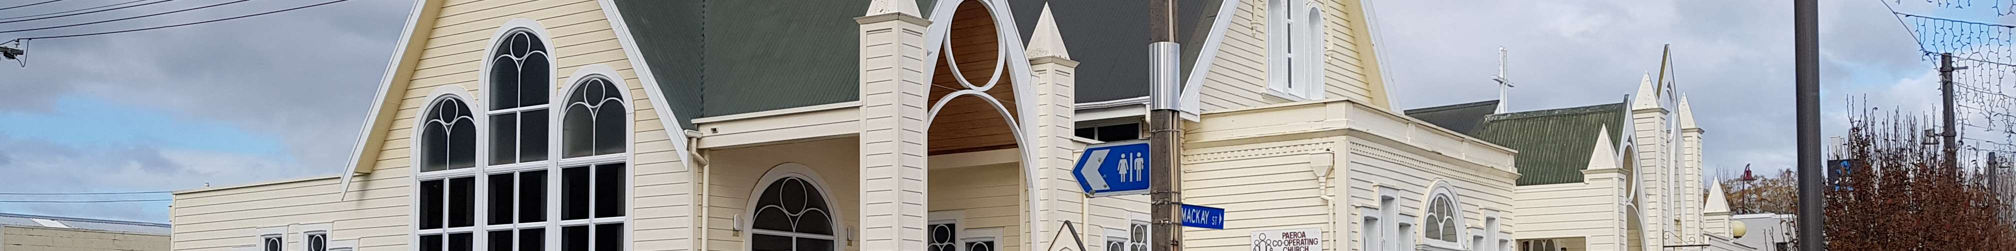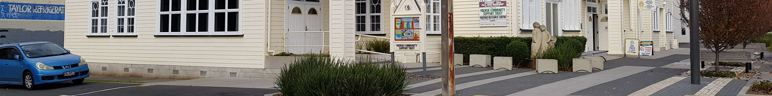
View of the church from the intersection of Willoughby and Mackay Streets
PAEROA COOPERATING PARISH STRENGTHS
- The Paeroa Cooperating Parish wishes to be a more “community facing” church.
- We are genuinely open to options and flexibility as to how to proceed.
- We have a good pool of lay preachers.
- We have an active Pastoral Concerns committee
- We have musical resources within our congregation.
- We seek to encourage the involvement of young people in our parish.
- Alternatives to worship services are provided via Coffee Church and Thinking Matters.
- The parish has a number of regular activities including weekly study group, weekly prayer meeting, fortnightly home group.
- Our physical church complex is attractive, centrally located, functional and well used.
PAEROA COOPERATING PARISH CHALLENGES
- While we touch a lot of lives in the community our formal congregation is not growing. We are having people join our congregation, but total numbers are decreasing.
• We need to bring people, particularly young people, into the church family. This evident in our appointment of a family worker.
* The age profile of our parish is weighted towards older people.
- Evangelism is not a strength of our parish. Going to the point beyond living Christ’s message (or attempting to), to discussing His message in one-on-one situations is a challenge for most of us.
Ngatea (Hauraki Plains Cooperating Parish)
The Hauraki Plains Parish based at Ngatea is smaller than Paeroa and while a little more traditional with an gentle Anglican flavour the parish shares a good bit of the dreams and vision of Paeroa. They readily identify with the Position Description produced by Paeroa (See below)

THE MINISTRY POSITION
Preamble:
This proposed ministry role is different from the ‘traditional parish minister’. For the sake of identifying our concept we have suggested the title ‘Spiritual Mentor’. The overriding intent for this ministry is to clarify and encourage our mission as the people of God.
The concept allows for the ministry to be shared with neighbouring parishes in the Coromandel-Hauraki area. Our thinking is that the majority of the parishes in this area are unable to sustain financially full-time ministry. However, we need to make clear each parish which participated would retain their own identity and continue to be responsible for their own affairs.
Attributes that would be important for a person considering this position.
Key Attributes
You will lead our multi-talented and willing church communities on their faith journeys, be a
part of their networks, guide and mentor their lay worship leaders and lead worship no more than once per month.
You will be able to help us to make the most of our existing community contacts to bring people into our church families
You will be able to share the message of Jesus Christ in a relevant way, to people of all ages.
You will be able to lead us in verbalising the teachings of Jesus Christ.
Desirable Attributes
Desires to be part of a team in the congregations that are open to new and innovative ideas
Can assist with effective Christian education programmes
Has skills to assist with pastoral care (as a backstop to our network in difficult situations)
Able to support a vision for the future, and have the self-motivation and time management skills to transform it into reality
Willing to join with our congregations in fellowship.
Commitment to Participating Parishes
There is flexibility as to how the percentage commitment in each parish could be structured. We see that the role and structure would be defined by the strengths and situation of the new parish leader. The appointee will need to be disciplined in adherence to the agreed percentage role in each parish. We understand that there may be a beneficial overlap in duties to each parish such as training of lay leadership, etc.
Congregational Input
The following areas are where individuals currently within each parish could take a leadership role.
The majority of pastoral care
Worship services (services in each parish are currently taken by members of the congregation).
Music (a pool of musicians participates on a rotational basis)
Congregation members usually lead the bible readings and prayers
The congregations are open minded as to ways to serve God. This call is an opportunity for our next leader to work with a great group of people to further God’s work in the Hauraki/Thames Valley.
Accommodation
There is a spacious home available in Paeroa for the incoming minister, however, should he/she prefer to use alternative accommodation, this can be discussed.
There is a similar modern manse available in Ngatea

