Ministry opportunity - Onewa Christian Community (North Shore, Auckland)
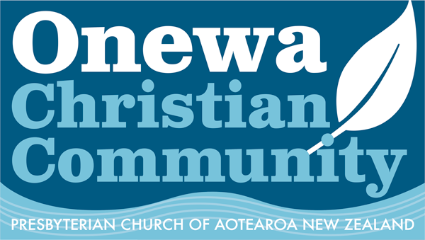
Onewa Christian Community is a new kind of local church that aims to have a positive impact in the diverse suburbs it serves.
With the support of mission funding from Northern Presbytery, this is a congregation committed to community engagement and building partnerships locally.
The Ministry Settlement Board is seeking expressions of interest from ministers who can bring their experience and enthusiasm to the ministry team. This is a 0.4 part-time, ordained position for an initial term of 2 years, working alongside lay members in the ministry team.
Interested ministers should refer to the website to get a feel for the life and vision of Onewa Christian Community. www.onewacc.org.nz
Position description and other supporting documents are available from the MSB convener, Rev. Martin Fey mart.fey@gmail.com

