-------------------

Vacancy

St George’s Presbyterian Church, Takapuna, North Shore, Auckland

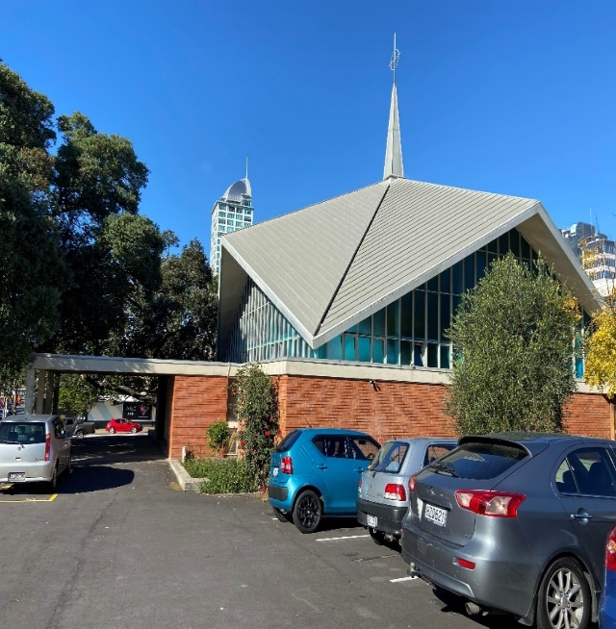
St. George’s is prominently located in the heart of Takapuna on Auckland’s vibrant North Shore. Also reflecting this is a strikingly modern manse located close by.

We seek a nationally ordained Minister to fill this vacancy arising from the retirement of our long-serving Minister. This is a full-time, sole charge position.

We are a warm and welcoming congregation whose membership gathers from all across the North Shore. We are looking for a leader who can continue to strengthen our faith and fellowship in our everyday lives. Building upon connections with many groups who use our facilities, we hope our new minister will help enhance our mission within our wider community.

If you see your future at St. George’s, please request our Parish Profile, 2022 Annual Report and the terms of call from:
Rev Dr Tokerau Joseph
Convenor, Ministry Settlement Board
tokerauj@gmail.com

Your application should be received with your CV, by Monday, 31 October.
--------------------

