

GA18 News

Wednesday 3 October – Sunday 7 October

Wednesday 3 October

Installation of Moderator Right Rev Fakaofo Kaio
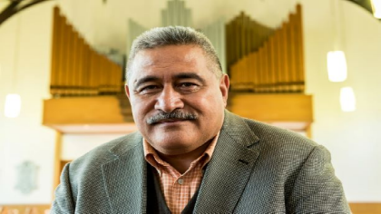
The 2018 General Assembly opened the evening of 3 October at St Andrew's College in Christchurch with a powhiri, followed by worship and installation of the new Moderator, Right Rev Fakaofo Kaio. The service involved the transfer of a ceremonial cloak (Te Korowai Tapu) and the laying on of hands by past Moderators.
Download images of the installation of Moderator Right Rev Fakaofo Kai.
View videos on the sermon delivered by Right Rev Fakaofo Kaio and the past Moderators prayer for Right Rev Fakaofo including the laying on of hands
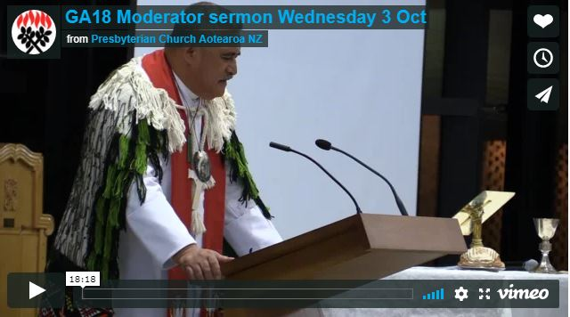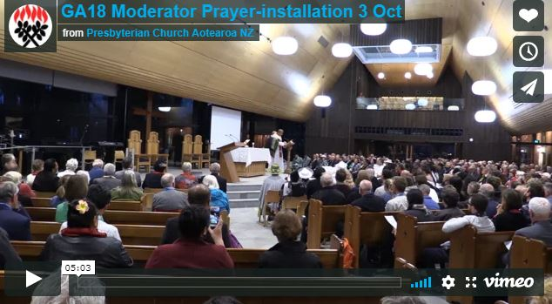

Youth Commissioner orientation day

Presbyterian Youth Ministry (PYM) had an orientation day with presbytery appointed Youth Commissioners at General Assembly on 3 October. Youth Commissioners had already undertaken training with PYM in preparation - watch the training video for new Youth Commissioners below. It's a useful introduction for all the Church's new Commissioners explaining how General Assembly works.


Ministers' Day
On Wednesday 3 October, 80 ministers gathered around the theme of life-long learning at the GA18 resourcing Ministers’ Day. Rev Dr Steve Taylor, Principal, Knox Centre for Ministry and Leadership says the day began with input from Rev Linda Hope, Rev Darry Tempero and Dr Rosemary Dewerse who lead a Bible study using original song, art and Scripture, to consider Jesus as a life-long learner. Afternoon workshops were led by staff from Kids Friendly, Knox Centre for Ministry and Leadership (KCML) and the Presbyterian Research Centre.
The day included the launch of a ministry resourcing website - https://livinglibrary.org.nz. The website is based on research commissioned by KCML in which over 280 leaders of the Presbyterian Church were asked “what the church needed to learn going forward”. Their responses were gathered into five thematic areas: Faith, Community, Witness, Leadership and Innovation and one delivery portal: the Living Library.
The Living Library recommends books and websites, videos and archival materials, short courses and provides webinar and coaching opportunities. It offers human stories in which the Church’s ministry agents offer their wisdom in ministry and provides access to BeWise, a leaders training curriculum. A Maori whakataukī encapsulates the hopes and dreams for this Living Library: He waka eke noa – naaku te rourou, naau te rourou, ka ora ai te iwi. Resourcing each other empowers each other to grow.

Thursday 4 October

Children are our future
Te Aka Puaho encouraged the Church to invest in its children and young people.
“Children are our future. My children and grandchildren are telling me that our congregations are full of old people, and not exciting,” says Marina Rakuraku, Te Aka Puaho Moderator.
“Te Aka Puaho is in a time of transition and we are having a look at ourselves and how we do things,” she says.
Marina highlighted that Ohope Marae hosted the first family youth camp in many years in 2017 and that another one was underway now.
“The 2017 event was very successful. It was a time of coming together for the young of Te Aka Puaho pastorates to plan for their future, to discuss where and what are we doing.
“My wish and my prayer for us is to bring children back. Without our children, there will be no Church.”
As well as the focus on young people, the Maori Synod’s report to Assembly noted structural changes within Te Aka Puaho, including the reinstatement of standing committees, as the Synod re-organises how it goes about its work and ministry.
Marina thanked Assembly for the grant which facilitated a face-lift on Te Maungarongo – the Church’s marae. Te Maungarongo has hosted a Council of Assembly meeting and the Knox Centre for Ministry and Learning interns have also had a live-in at the marae and visited several local pastorates as part of their training.
The report also noted the joy of licensing six new Amorangi ministers since the 2016 General Assembly.
The passing of former Te Aka Puaho Moderator, Mrs Millie Te Kaawa, was acknowledged as a sad time for not only Te Aka Puaho but the wider church.
Te Aka Puaho’s report to Assembly also expressed sadness at the closing of Turakina Maori Girls College which had educated many Te Aka Puaho kaumatua.

International Guest Rev Tui Sopoaga celebrates long connection with Moderator
Assembly guest Rev Tui Sopoaga addressed Assembly today in his role as chairman of the Tokelau Congregation Christian Church of New Zealand and Australia.
The Tokelau church has been independent since 1996. “We decided we were old enough to move out by ourselves,” Rev Tui chuckled.
Tokelau’s population has dwindled to 2,000, with 7,000 Tokelauans now living in New Zealand. Moderator Rt Rev Fakaofa Kaio grew up with Tui’s wife Ane in a small hut that has long since been destroyed in a cyclone.
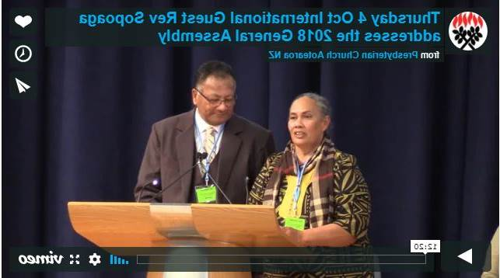
Ane presented the Moderator with a traditional lei woven by an 82-year-old Tokelauan woman, and the couple were joined on stage by other members of their Wellington congregation to sing a waiata. Watch below.

Assembly encouraged to acknowledge that it's all God's money
PressGo is asking General Assembly to consider setting up a task group to examine the Church’s collective wealth and establish a theology and practice of sharing property and money.
Commissioners will consider the matter more fully in dialogue groups.
Sharon Ross Ensor, acting PressGo chairperson, drew commissioners’ attention to the fact that despite declining membership, the Church’s wealth is increasing.
“The Church has significant material blessings. A recent report from the Church Property Trustees estimates that the Church owns property valued at around $1.2b.
“We believe that it’s time for a Church-wide conversation about our collective wealth along with developing resources on the theology of sharing, property and money.
“We wonder what transformation would happen if we practice generosity in costly ways, as shown in God’s generosity and abundance to us,” says Sharon.
Jenny Flett, also on the PressGo board, shared a story about “giving forward” that she believed demonstrated a theology of wealth sharing, and invited dialogue groups to tell their own stories of abundance, generosity and transformation as they considered the proposal to establish a task group.

Outgoing Moderator’s address

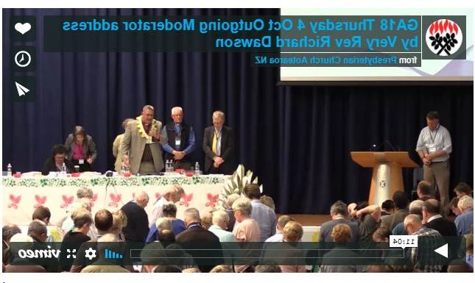
The Very Rev Richard Dawson gave his outgoing Moderator’s address to Assembly. Watch the video.

Assembly considers ethics
Commissioners today considered the Church’s Code of Ethics in dialogue groups.
Although the updated Code has been ratified and published since March this year, as one of Church’s important documents, it is vital for the safety of those in the Church’s care as well as our leaders, that Assembly considers the Code, says Rev Dr Kerry Enright of the Book of Order Advisory Committee.
“We are accountable to God, but we are also accountable to the communities that we are part of,” says Kerry.
In preparation for dialogue groups, Kerry asked commissioners questions that challenged the Church’s ethical standards: “Is it OK for a male minister to put his arm around a young woman without permission? Can a male elder drive a woman home alone? Is it OK for a minister to share a confidential conversation with his or her spouse?”
“Every day we are making judgements about how to behave ethically,” says Kerry.
Kerry noted how the Australian royal commission into sexual abuse had been a wake-up call for Australian churches and confirmed that the Presbyterian Church has asked to be part of the New Zealand royal commission into historic abuse in state care.
The Very Rev Pamela Tankersley – also a member of the Book or Order Advisory Group – talked about the importance of supervision, and outlined five areas for improving the climate and culture around ethical decisions.
Pamela invited dialogue groups to offer suggestions on other actions that the Church could take to strengthen our ethical approach.
Assembly will hear feedback from dialogue groups tomorrow.

Media coverage
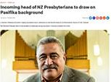
Listen to Moderator Rt Rev Fakaofo Kaio talk to Radio New Zealand about his background and plans as Moderator of the Presbyterian Church.

Youth Commissioner profile
Each day of General Assembly we profile one or two of our presbytery Youth Commissioners.


Mevia Faletoese - GA youth commissioner, Northern Presbytery
Mevia Faletoese says she “wanted to serve as a young adult commissioner at GA because I knew that it would be a rewarding experience. A great opportunity to participate and contribute to a national platform that values the ideas and voices of young people”.
However, most importantly for Mevia, by serving “as a young adult commissioner I too can encourage other Pacific Island young adults to become more actively involved within all three courts of the Church”.
“I believe that it’s important for young adults to be involved in the decision-making of the Church because we are an integral part to the life, the growth and the future of the Presbyterian Church. We contribute greatly to the vibrancy of the body and we have so much to give.”
Mevia says that the Presbyterian Church has made a great investment by including the voice of young people and allowing young people to serve as commissioners.


Nadia Risdale - GA youth commissioner, Presbytery Central
Having grown up in the Presbyterian Church, GA youth commissioner Nadia Risdale says she values community formed through Christian faith and built on corporate worship.
“I am grateful for the opportunity I have been given growing up to be part of this through St Albans and Presbytery Central. I wanted to be a youth commissioner for a few reasons. Through interning at St Albans and studying through Pathways Bible College in 2017, I realised that I want to work in ministry in the future. I think being a commissioner and seeing some of the ‘behind-the-scenes’ work of the Presbyterian Church will be a valuable experience and a great opportunity to make connections with others. Also, I appreciate the tradition of having youth commissioners at General Assembly. I believe young adults aren’t just the future Church, but they are the Church of today; so it is important our voices are represented.”
Nadia says that General Assembly is “an opportunity for Christian traditions and beliefs to be reinforced in the context of the Presbyterian Church and taught to a younger generation”.

Keynote Address - Rev Ned Ripley
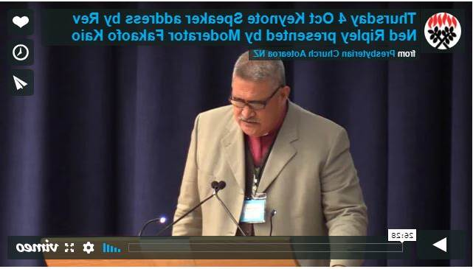
Due to the Rev Ned Ripley being taken seriously ill on last week, the Moderator Right Rev Fakaofo Kaio read Ned’s prep-prepared keynote address for him. He then called for the Assembly to join with him in prayer for Ned and his family.
Rev Ned Ripley was raised in American Samoa, he later trained for ministry in Auckland with the Congregational Church.
From the early 1980s, he was Dean of Maori & Polynesian Studies at the Church’s Theological Hall in Dunedin.
Ned was minister of Otara Pacific Islanders Church for 15 years. He retired from ministry in 1989.
He was awarded the Queen's Service Medal for Public Services (QSM) in 1982 and is a Justice of the Peace and an elder.

Ministry Enterprise Fund exemption clause change
Assembly agreed to a proposal from Council of Assembly that addresses an anomaly in the exemption clause for contribution to the Mission Enterprise Fund.
Under previous rules, a parish could only be exempt from contributing 10 percent of the net sale proceeds of a parish property to the Mission Enterprise Fund (MEF) if a manse was being sold to replace a manse, or a worship centre sold to replace a worship centre.
Manse sale proceeds used to fund a new worship centre did not qualify for the exemption, and vice versa.
Assembly agreed to amend the relevant supplementary provision to address the anomaly. Council of Assembly convenor Jenny Flett said that the change was consistent with the spirit and intent for contributions to the Mission Enterprise Fund.
Assembly noted that some parishes have been unfairly disadvantaged by the inequity of the exemption clause.
To address this inequity, Assembly resolved that PressGo could make grants equal to the amount contributed to the MEF to parishes where the Council of Assembly agrees that the parish would have qualified for the Mission Enterprise Fund exemption, as adopted by this General Assembly – if this wording had been implemented by the 2014 General Assembly.
Assembly approved a grant to Whakatu Presbyterian Parish, and invited any other parish that believes it meets the criteria, to apply to the Council of Assembly by 31 May 2019.
The proposal attracted a couple of questions of clarification from commissioners, one of which sought clarity about the definition of worship centre. Jenny confirmed that it was her understanding that “worship centre”, as expressed in the amended clause, included a hall.

Changes to BOO align new presbytery structure
Assembly today accepted recommended changes to the Book of Order.
The Book of Order Advisory Committee presented changes that provide for the different ways that the Church’s now very large regional presbyteries need to function including:
• the appointment of a presbytery council, with full powers of presbytery, other than for budget considerations and voting on matters referred under the special legislation procedure.
• the introduction of deputy presbytery moderators
• provision for decisions to be reviewed by the presbytery council, which allows for contentious matters to be re-considered before they get to the appeal stage
• provision for presbyteries to conduct their business by electronic communications.
“These changes give consistency and clarity to what is already working in practice,” says Convenor Pamela Tankersley.
The process for dissolving a congregation now references the fact that minister’s entitlements persist for six months from the date of dissolution, which resolves any ambiguity.
Assembly agreed that a delegate of the convenor of the ministry settlement board could moderate a congregational meeting called to elect members to the ministry settlement board. Under previous regulations, only the convenor could fulfil this duty.
Changes subject to the special legislative procedure were also approved and will be sent to relevant Church courts for consideration.

Important documents get overhaul
Comprehensive changes to chapter 15 of the Book of Order, which deals with discipline, will be brought to the 2020 General Assembly.
This is a major body of work, said Pamela Tankersley, convenor of the Book of Order Advisory Committee (BOAC), and the changes will take into account recommendations from the 2016 task group which examined the Church’s disciplinary processes, as well as current procedures in the Church, compliance with secular law and current practices in other churches and voluntary institutions.
“We hope to incorporate in the revised chapter learnings from Maori and other cultures within the Church, particularly on restorative justice and mediation processes,” says Pamela.
The BOAC chose not to take further action on the use of social media during Assembly, largely because any regulations would be unenforceable. Instead, the committee felt commissioners should commit as a matter of principle to “keeping Assembly matters within Assembly,” Pamela reported.
The BOAC also updated the development of a comprehensive Child Safety policy. The new policy will be submitted to the Council of Assembly for approval as a Supplementary Provision as soon as it is available.
Updates to the Conditions of Service Manual and the Code of Ethics, which were issued in March 2018, were ratified by General Assembly. The manual was long overdue for an overhaul, and it now reflects current employment legislation, along with content more sensibly arranged for easy use by congregations.
The Church’s revised Code of Ethics is now a stand-alone supplementary provision rather than being part of the Conditions of Service Manual.
In addition to ratifying these important documents, Assembly also approved a raft of technical changes to the Book of Order to make it more consistent.

Northern Presbytery hits the refresh button
The Northern Presbytery embraces over 100 churches. Casting its net far and wide, the presbytery has recognised the need to rethink its structure and how it operates.
Assembly heard today more detail on what that has meant in 2018. Five regions have been established to develop and implement ministry and mission, while the Presbytery Council takes on a governance role.
Youth director Gary Maunga reported that a review of youth ministry work confirmed the value of the current youth coordinator role.
“We’ve also formed a youth forum with reps from each parish who organise events and contribute to the twice-yearly full presbytery meetings,” Gary says.
Moderator Steve Millward greeted Assembly in the multiple languages of his congregation members and explained how he sees his role as a connector, sharing the Good News and inspiring people to come together as agents of change. “We hope Northern Presbytery can say in future that God is able to do more than we could possibly imagine,” he says.
Emma Keown explained that the presbytery has engaged two senior ministers to review how it can best support Asian congregations. They are also reviewing the three Presbytery campsites for optimal use in ministry and mission.
“We also have a big goal to review all of our congregations over the next two years,” she adds, “and have appointed a part-time parish reviewer to help us with this audacious task.”

Moderator’s role in mission clarified
Today Assembly agreed that the Moderator has five key areas of activity:
- Moderating General Assembly
- Undertaking ceremonial and celebration activities like representing the Church at national and international ecumenical and cultural events
- Mission
- Being a pastoral presence around the Church
- Contributing to policy formation.
When it comes to mission, Assembly agreed that the Moderator’s core tasks are firstly to listen and share the missional direction of the Presbyterian Church with members of the Church, and secondly, to engage directly with Presbytery leadership to inspire and encourage mission at all levels of the Church.
Clarification of the Moderator’s role in mission came as a result of a comprehensive review of the Moderator’s role and function undertaken by a task group established by General Assembly 2016.
A 2004 report to General Assembly was the starting point for the task group, who also consulted extensively with the wider church in coming up with the recommendations presented to this Assembly.
The task group’s report to Assembly says that the area of mission leadership was problematic because “confusion reigns about who the primary agents of mission are within the Church,”.
To clarify issues around role and function of the Moderator and his or her role in mission, the work group went back to what it is to be "Presbyterian" in terms of the Church’s theology of leadership.
As well as agreeing to proposals about the Moderator’s tasks, Assembly also agreed to recommendations about the Moderator’s term, stipend and expenses and the process for electing the Moderator [see story below].

More diversity sought in Moderator nominations
A new process for calling and electing the Church’s Moderator was among changes to the Moderator’s role agreed to today by Assembly.
The Moderator Review task group, established by the 2016 General Assembly, bought a series of recommendations that clarify the Moderator’s tasks [see previous story on tasks] the modertorial election process, the Moderator’s stipend and expenses and other matters.
In changes agreed to today, parishes will now be able to nominate up to four people who must reflect lay and ordained, male and female, and the multi-cultural diversity of the Church.
Parishes may nominate suitable candidates from anywhere in the country and nominees do not necessarily need to come from their presbytery area. Presbyteries are now required to seek nominee permission before putting forward names.
The step of shortlisting candidates before stage one voting has been removed (it was needed when there were 23 presbyteries, but is no longer necessary).
While the proposal eventually lost, an amendment from the floor of Assembly which sought to stipulate that presbyteries must nominate a man and a woman in the final round of nominations attracted much debate.
Those opposed to the amendment indicated that it would prohibit presbyteries from nominating two women, and that such a stipulation failed to acknowledge the skill set of candidates.
Those who supported the amendment indicated that the existing provisions encouraging diversity are not working, and pointed to the fact that the Church has only had four female moderators as evidence.
In making the recommendations to Assembly, Peter Dunn of the Moderator Review Task Group, acknowledged that legislation is a blunt instrument that will not necessarily bring change, but that what the task group presented were “aspirational recommendations”.
Assembly agreed that Moderators may only serve a single term, and each term could be up to full time for a period of two years.
In response to concerns that the incoming Moderator or their parish bears an undue financial burden in the lead-up to their installation, Assembly agreed to fund the incoming Moderator for a period of six months before he or she starts their term. They will be supported by the Presbyterian Church on a .33FTE benchmarked to the stipend structure.
For their term, a stipend-based remuneration will be negotiated with the Moderator, so that neither he or she, their congregation, or their employer will be financially disadvantaged during their term.
Assembly also agreed that allowance be made for the Moderator’s spouse or other support person to accompany them when travelling.

Celebrating women in ministry
Moderator Rt Rev Fakaofo was presented with a copy of a research report into women in ministry.
Women of the Burning Bush: Still Burning 25 Years On is a study of women in ministry within the Presbyterian Church of Aotearoa New Zealand. The research, led by Dr Vivienne Adair, follows research commissioned by the Very Rev Margaret Reid Martin in 1990.
Rev Sharon Ross Ensor, who was part of the research oversight group, indicated that the overall impression from the research was that the Church’s women ministers are a group who are committed and passionate about ministry path that they are on. Sharon said that one of the main differences between this research and that of 25 years ago is that women are accepted as competent ministers and more women are satisfied with their accomplishments.
“We acknowledge those women of courage, tenacity and vision who have gone before us,” says Sharon.
“It is clear that this report is not something to be filed away as a snapshot in time,” says Sharon. “We want it to be a platform for further dialogue and conversation.”
In accepting the report,

In Brief:
- The memorial minutes of 19 ministers who have passed away since last Assembly were placed in the records of General Assembly 2018.
- General Assembly acknowledged the anniversaries of ordination. The Moderator conveyed warm congratulations and the greetings of Assembly to those who would pass this milestone before the next General Assembly.
- Assembly received the audited accounts for the year ending 30 June 2018. The Council of Assembly was authorised to sign the audited accounts on behalf of General Assembly.
- A range of technical corrections to the Book of Order were approved by General Assembly.
- Assembly ratified Supplementary Provisions that have been adopted by Council of Assembly since the last Assembly

Devotions
Rev Dr Kerry Enright led devotions this morning at Assembly. Download the Litany here

Friday 5 October

Archbishop Richardson seeks Church’s forgiveness
In an address to Assembly today, Anglican Archbishop Most Reverend Philip Richardson expressed his remorse that his church had not been sufficiently active in reaching out to its fellow Christian churches in recent times.
“Ecumenical partnerships have been on the back burner for too long,” he said. “I ask the Presbyterian Church’s forgiveness for our failures as partners in faith.”
The archbishop spoke on behalf of the trinity of archbishops of the Anglican Church of Aotearoa, New Zealand and Polynesia.
“We are three in one and can’t make decisions without the agreement of all,” he explained, before going on to talk about his passion for partnership.
“Ecumenical formation and direction is in my DNA,” he said, describing his own formative years in Dunedin mingling with theological students from Knox and the Holy Cross Seminary.
He reiterated that the common ground of Christian churches in Aotearoa stems from a shared understanding and experience of being a Treaty-based and Gospel-driven people.
The archbishop’s words were greeted warmly by Assembly and his wish to see greater depth and commitment to partnership was received unconditionally by the Moderator Right Rev Fakaofo Kaio, who said they echoed what was in the Presbyterian Church’s hearts and prayers. On behalf of the Church, Right Rev Kaio in return humbly sought the forgiveness of the Anglican Church for “the lack of closeness” up to today between the two churches, before praying for both churches and the future relationship together. Watch the video:
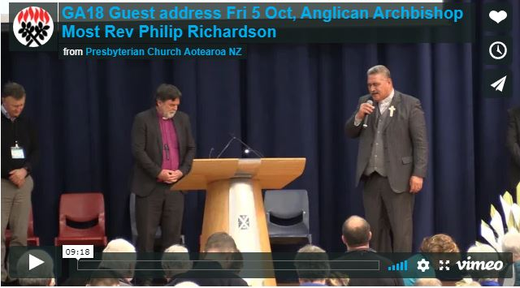

Sharing wealth and streamlining release of funds
In presenting the the PressGo Board report, Rev Sharon Ross Ensor, acting PressGo chairperson, thanked Lisa Wells, PressGo Catalyst, for her ongoing work and noted that PressGo continues its focus on three strands: inspiring mission, capacity building and seed funding.
She noted that PressGo would launch a new mission programme in 2019 and said the Board hopes the Assembly will talk about the Church’s collective wealth.
Dialogue group facilitators reported back on the PressGo recommendation that a task group examine the Church’s collective wealth and establish a theology and practice of sharing property and money.
The Rev Hamish Galloway presented some of the themes that emerged from dialogue and the recommendation was agreed.
A second recommendation that the task group consider the Church’s collective wealth and consult widely within the Church and make recommendations to the 2020 Assembly for a national strategy for sharing resources was amended before it was agreed to - with the word strategy changed to framework.
Rev Dr Kerry Enright said that dialogue group felt ‘strategy’ implied time lines and ‘frame work’ suggested congregations engaged in discussion and decisions that are not made alone.
A new motion emerged from Dialogue groups and was presented by the Rev Simon McLay: that the General Assembly instruct the task group to explore ways to both simplify and streamline the process of churches to access funds, especially supporting our ethnic churches.
The motion was inspired by a need to “streamline the process to release funds to support ethnic churches and make the process easier to access funds such as the PIF, PressGo, Presbyterian Foundation, local and regional funds. So churches can use these funds and don’t have to know the particular words needed to apply,” said Simon.
After several questions around the definition of “ethnic churches” the motion was amended and agreed with the reference to ethnic churches removed.

Very Rev Margaret Schrader Keynote address goes to heart of God
The Very Rev Margaret Schrader gave today’s keynote speaker address. She is one of only four women to be have been elected Moderator of our Church (1995).
Described by Right Rev Fakaofo Kaio as a “prayerful warrior” and “God’s taonga” Marg was invited to speak about God. She shared personal reflections on who God is for her as a living presence, and asked Assembly to reflect on how they might make space in their own lives to get in touch with the call of God to do something unexpected that resonates with their authentic self. Watch the video of her address:
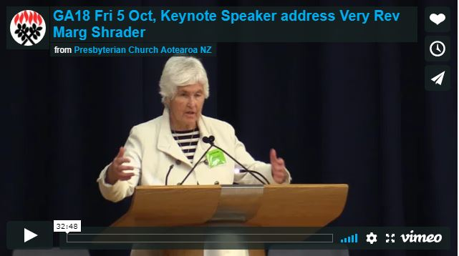

National ministries share their love
Assembly business opened this morning with inspiring presentations from national ministry leaders.
Knox Centre for Ministry and Leadership
KCML principal Rev Dr Steve Taylor described 2018 as a year of listening to the kinds of resources the Church needs as a learning organisation. In response to the feedback from 285 church leaders for resources to be available in flexible, accessible ways, the centre has developed a new Living Library.

The library portal at www.livinglibrary.org.nz offers recommended books and websites, videos and archival materials, short courses, webinar and coaching opportunities, human stories and more. The site is live for feedback during Assembly.
Presbyterian Research Centre
Presbyterian Research Centre director Jane Thomsen focused on the growing mana of its special collections and how the centre has been addressing the lack of women’s voices in its collections.
The Archives now hold the taonga of Turakina Maori Girls College, which closed in 2016. Otago University Humanities interns have contributed welcome material on the role of Presbyterian women as medical missionaries in India and moderators of General Assembly.
Another intern is researching the role the Church played in bringing Chinese refugees to New Zealand in the 1940s and 1950s, and the centre expects to receive archives from several Chinese families with links to the Otago goldfields.

Presbyterian Youth Ministry
Presbyterian Youth Ministry manager Gordon Fitch and Presbyterian Youth Ministry director Matt Chamberlin introduced a video on their work, watch it below.

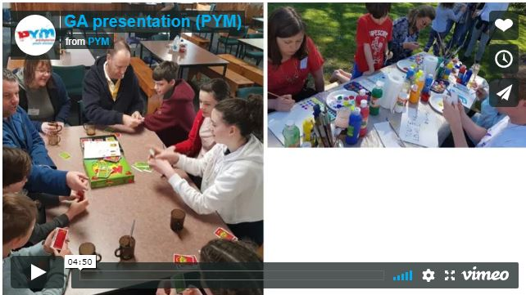
PressGo
In the past 10 years, PressGo has funded 65 projects worth $2.9 million in grants. PressGo catalyst Lisa Wells delivered a series of challenges, in response to the many conversations she has up and down the country with Churches seeking funding for new projects.
“We tend to look at Church as a problem to be solved with ‘what’ and ‘how’ questions, but I suggest we start with the question of why,” she said. “What’s our mission?”
She challenged older members of congregations to resist becoming observers and ask instead they can do to lead, embrace and extend their gifts.
Lisa also highlighted the need for a model of generosity that would see parishes sharing wealth on a more equitable basis.

Global Mission
Global Mission coordinator Rev Phil King is away on leave. Assembly saw a video presentation of the work of Global Mission, watch below.

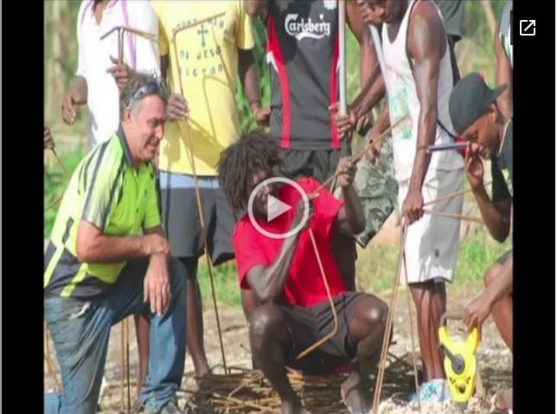
Kids Friendly
Kids Friendly has a new national coach. Robyn Humphries moved from the USA to New Zealand six months ago to take up the role and said she has found the 14-year-old ministry standing on solid foundations.
To the backdrop of her 18-month-old daughter mimicking Holy Communion, Robyn used the four-fold ‘take, bless, break and give’ actions to describe the ethos of the Kids Friendly approach and its natural outgrowth as a successful mission for the Church’s youngest members. She exhorted commissioners to be generous in their ministry and to “give it away” to God as an expression of greater purpose.

Finance
Finance manager Sandra Kennerley concluded the presentation session with a wrap-up of the year for Financial Services, praising her team and the efficient work they do in preparing the annual report, helping parishes comply with ever-changing accounting requirements and undertaking administrative support.

Youth Commissioner profile

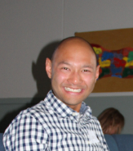
Feng Chen - GA youth commissioner, The Southern Presbytery
GA youth commissioner Feng Chen (or he says you can call him Ryan Feng) hails from Wakatipu Presbyterian Community Church in Queenstown.
“I am a ‘newly converted’ Presbyterian and becoming more thoroughly Presbyterian if I may say. My local church and the Southern Presbytery have provided me with excellent support and resources to explore NZ Presbyterianism and grow maturely in faith as a person and a ‘younger’ leader.”
Feng Chen says he wanted to be a youth commissioner “because I want to explore more about Presbyterianism at the national level and be more familiarised in the spirituality, ethos and the governance of PCANZ. I believe this will help shape my understanding of the Church and ministry formation”.
He says he sincerely believes youth commissioners at GA, and younger leaders in the Church in general, are essential for the healthy and sustainable development of the Church.
“We are like the ‘Timothy(s)’ that Paul talks about in 2 Tim 2:2, someone who received the pure Gospel from the last generation and is able to ‘pass on the baton’ to the next generation. In this process, the younger leaders bring in their indispensable energy, innovation, vision and courage to faithfully nurture and reform the Church according to the Scriptures.”

Make the Church’s voice heard
Presbyterian Women asked the Church to more fully engage with social justice issues.
They asked, and General Assembly agreed, to support and encourage presbyteries to institute an agile process to facilitate participation in civil democracy through submissions on public issues.
Participating in civil society means commenting on social issues says Ola Leasi, newly appointed president of Presbyterian Women.
Presbyterian Women has taken up this opportunity and made a submission on Child Poverty Reduction Bill, for example, says Ola. She noted that making a submission is a time-consuming process.
At their recent Annual General Meeting, Presbyterian Women decided that it would create position papers to provide a framework for public discussion on topics that are of interest to women and the wider community.
It is envisaged that one to two position papers would be produced each year, as time and resources allow, explained Ola.
There was broad support from commissioners for the proposals from Presbyterian Women. Some speakers raised the point that Presbyterian polity already allowed any group within the church the opportunity to comment on public issues and make submissions should they wish to do so.
Others commented that it might be more efficient to have a national framework rather than having each presbytery developing its own process.
“These are aspirational recommendations,” Ola told Assembly.
To improve the ability of women to participate in the life of presbytery and account for the changing structures of Presbyterian Women, Assembly agreed to change the Book of Order regulations on presbytery membership. New rules agreed by Assembly provide for “at least two representatives of Presbyterian Women Aotearoa New Zealand chosen by the executive of that organisation to represent them”.

Assembly backs work of Presbyterian Support
Assembly encouraged presbyteries and congregations to continue joint activities with Presbyterian Support.
General Assembly asked the Council of Assembly to consider continuing the Church’s annual financial contributions to the New Zealand Council of Christian Social Services (NZCCSS) and PresCare in its next budget.
PresCare is the partnership between the Presbyterian Church and Presbyterian Support which is aimed at building safe, strong and connected families explained Anne Overton of Presbyterian Support.
Anne shared stories of the many activities that PresCare had been involved with since its inception six years ago including the Kids Friendly Love Reaches Out art and writing competition, Neighbours Day events, White Ribbon events and the Justice and action study booklet which has been used in parishes and Presbyterian schools.
“The Church can be satisfied its voice is being heard,” says Penny Taylor of Presbyterian Support. Rev Diane Gilliam-Weeks represents the Church on the New Zealand Council of Christian Social Services, and the Council is represented on the government’s Welfare Expert Advisory Group by our chief executive Trevor McGlinchy, says Penny. She also highlighted the twice-yearly meetings between the Prime Minister and heads of church.
At the end of their presentation, Moderator Rt Rev Fakaofo Kaio prayed for the work Presbyterian Support.

International guest address by Rev Tere Te Akaraanga-Marsters
Rev Tere Te Akaraanga-Marsters addressed Assembly today - download his address.
Tere is an executive council member of the Cook Islands Christian Church (CICC). He was elected Principal of Takamoa Theological College in 2017. He is responsible for the academic studies and management of the College, where he served as a faculty member and lecturer since 2013. He was the Chair of the Takamoa Theological Board from 2014 to 2017.
He also served in 2017 as the minister of Titikaveka Cook Islands Christian Church in Rarotonga.
Tere says he was chosen to represent the Cook Islands Christian Church at GA18 “because of my position as Principal and Executive Council Member. This opportunity would allow me to broaden my perspective of the relationship between partner Churches and to meet key leaders within the Pacific region. Also, to look at the possibility of forging ongoing relationships with other theological colleges and institutions”.
Tere grew up in a close-knit Cook Islands community in Frankton, Hamilton. He has visited Christchurch once before, “in 1975 for five days…to watch the All Blacks play”.
Watch Tere's address to the Assembly:
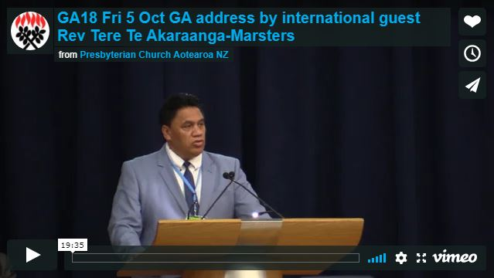

Church supports Korean reunification
General Assembly today expressed its support for steps made towards peace between North and South Korea.
Assembly asked that a prayer for peace be written and distributed to all congregations so that New Zealand Presbyterians can pray together as one body of Christ for peace on the Korean peninsula.
Cheol Jeong of Northern Presbytery who presented the proposal to Assembly talked of positive signs toward peace in the last year, including three meetings between the North Korea Supreme Leader Kim Jong-Un and South Korea President Moon Jae-in.
“Koreans living in New Zealand are happy to hear the progress toward dialogue and not confrontation,” said Cheol.
“There is still a long way to go, and we hope that the meetings and other actions will translate into action to turn Korea into a land of peace that is free of nuclear weapons,” said Cheol.
Korea has been divided into two separate countries for 70 years since the end of World War II – with the south supported by the United States, and the north supported by the Soviet Union. The Korean War from 1950-1953, sought to resolve the issue of sovereignty but ended in a stalemate.
“We need God’s grace, miracle and your prayer,” Cheol said.
Assembly affirmed that through our belief in God, we are called to be peacemakers, and can bring peace to the painfully persisting conflict on the Korean peninsula so at to enable reconciliation and restoration between two countries of one people.

Accra Confession commended to congregations
Today Assembly decided to send the Accra Confession to congregations and presbyteries for study.
The Accra Confession was adopted by the World Alliance of Reformed Churches (a predecessor body of the World Communion of Reformed Churches of which the Presbyterian Church is a member) in Accra, Ghana in 2004 to address issues of economic justice and the destruction of the earth.
“Even though it is 14 years old, it is still relevant today,” said Rev Dr Kerry Enright when he presented the proposal to Assembly.
“The Confession is a theological reflection on what is happening globally and what we are seeing locally. It is a resource from the wider church to animate thinking about how we can be church today here in Aotearoa New Zealand,” said Kerry.
In their report to Assembly, Southern Presbytery who bought the proposal on behalf of Knox Presbyterian Church Dunedin, said that the Confession provides a framework for how Christians can confess their faith in Aotearoa New Zealand in a context of extreme poverty, inequality, climate change, environmental degradation and other social issues.
There was limited debate on the proposal, with a small number of commissioners speaking against the recommendation to commend the Accra Confession to congregations for study.
Read the Accra Confession.

Making the Church’s voice heard
Assembly agreed to several recommendations aimed at resourcing the Church to speak out on social issues.
General Assembly firstly affirmed its understanding of “social voice” to mean both words and actions.
Exercising a ‘social voice’ in today’s environment requires more than a committee that will issue statements on various issues, as we have tended to do in the past.
“In simple terms, what we do is the most effective way for us to say what we believe concerning social issues,” says Social Voice Work Group convenor Richard McLean, who presented the work group’s report to Assembly.
Assembly encouraged the Moderator to form close working relationships with the heads of other organisations with a social voice, and to be alert to the possibility of issuing joint or complementary statements on issues of the day.
General Assembly also encouraged presbyteries to engage with the Social Voice Work Group Report and to identify, initiate and support networking opportunities in their regions.
The work group’s report includes a list of resources that congregations can use to inform their activities, and also calls for the development of virtual and real networks to share ideas and develop understanding of what is being done by parishes around the country.
Some commissioners expressed disappointment that the report did not specify the many social justice issues they grapple with such as racism, prison reform and #me too. Citing the Rainbow community as an example of young people ending up on the streets through lack of familial acceptance, Assembly was reminded that the Church needs to be asking itself how it contributes to some social ills.
Commissioners saw the report as a small step on the path of a longer journey, and hope to see a more robust and visionary report be presented at the next General Assembly.
Read the Social Voice Work Group Report to General Assembly.

Pacific Presbytery grows new parishes and leaders
The Pacific Presbytery (formerly The Pacific Islands Synod) report to General Assembly presented the strength in diversity of Pacific peoples in the Church.
Pacific peoples are predicted to reach 10 percent of the New Zealand’s population by 2026. What unites these communities are shared values, says presbytery clerk Mr Leilua Timaloa.
“Family, community, relationship & connectedness and being faith-based are the four core values weaving this young presbytery together on ‘one pandanus mat’.”
The presbytery oversees 15 parishes including 4 new parishes created in the last two years. Ekalesia Kelisiano Niutao Tuvalu PIPC – one of the new parishes - is the first ever Tuvalu congregation established within the Presbyterian Church of Aotearoa New Zealand.
“The formation of the PI Synod gave these parishes extra motivation to take the leap of faith and apply for full membership as recognised parishes within the Church,” Leilua reported.
The majority of Pacific islands’ people in Aotearoa (55%) are under 25. Growing the next generation of leaders and ensuring the Church is relevant and connected to young people are key challenges and opportunities facing their ministry.
Another central issue is that, although spirituality is still deeply held, Pacific island churches are struggling to maintain the momentum of growth last seen in the 1980s and 1990s.
New Zealand born Pacific Islanders who grew up in the PIPC churches are now often attending worship in a different denomination other than a PIPC church.
Among the recommendations to come out of the Pacific Presbytery business committee planning session held in March this year, says Leilua, was building for the present and future Pacific generations to treasure and maintain their cultural roots but to also have the freedom to express their faith and worship in a way that will honour and serve God.
The Pacific Presbytery has also been focusing on increasing its pool of leadership and the session wrapped up with a series of images documenting the induction of lay preachers and new ministers inducted to serve at Glenfield PIPC and Ranui PIPC parishes in Auckland.

Rules to change for Cooperative Ventures
Assembly approved a request from the Uniting Congregations of Aotearoa New Zealand to change the Procedures under which Cooperative Ventures operate.
Changes agreed to today make financial assessments compulsory, not voluntary as at present. The Partner Support Fund, in place since 1988, will be replaced with a new funding model.
The other major change is that the existing role of coordinating partner [denomination] will now be split into two roles: Convening Partner and Appointing Partner.
The Convening Partner will rotate among the Partner denominations every three years. The Convening Partner (national/diocesan) will be responsible for determining and collecting the assessment/quota for each cooperating venture parish. Regional levies will also be paid where appropriate.
The Appointing Partner is essentially responsible for supporting the minister, and this rotates with changes in the minister.
Of the 117 Cooperative Ventures in New Zealand, 107 include Presbyterian as one of the partner denominations.
Council of Assembly expressed reservations about endorsing the changes saying it had concerns about where risk management lies between the partner churches under the new model. Council was also uneasy about financial implications for the Presbyterian Church of the proposed change to funding model.
UCANZ representative Adrian Skelton provided context to the amendments, particularly the degree of consultation that has gone into producing them. He explained that although the suggested target for contributions to the current fund is a minimum of three percent of gross income, this level of contribution is not compulsory and hence the fund has fallen dramatically in recent years.
Many commissioners had procedural questions and contributed to the lengthy discussion about the relative merits of the changes.
Those in favour of the proposals – typically from Cooperative Venture congregations – said that it has been 21 years since the Partner Support Fund came into being and it was time for a more equitable system in which parishes pay proportionately to their income to each Partner in turn.
Among the dissenting voices, the amendments were described as “a suicide pill” - disruptive, premature and unnecessary.
The changes will take effect from 1 July 2019.

Saturday 6 October

Assembly says ‘No’ to euthanasia
Today Assembly strongly affirmed that it does not support provision for euthanasia and medically assisted suicide as proposed in the End of Life Choice Bill.
This decision was taken on the grounds that legally sanctioned provision for doctors to actively end people’s lives or assist their suicide is ethically unacceptable and would in the long term be dangerous for public safety especially for those who are seriously ill, depressed, disabled, or very elderly.
Assembly urged Parliament to respect the dignity and value of all human lives, to protect the lives of society’s most vulnerable, and not to pass the Bill.
The Doctrine Core Group’s comprehensive 16-page report notes that according to the Old Testament, God creates, grants, and determines the length of life, and that the Bill contravenes the foundational biblical principle that people should not kill one another.
“Every human life is intrinsically valuable, irreplaceable, and worth preserving, even during times of intense suffering,” says group convenor Rev Dr Stuart Lange.
Speaking in support of the proposals, commissioners pointed to the great work hospices do in palliative care and said that anecdotally less than one percent of those terminally ill could not have their pain relieved. The report also states that the Bill is medically unnecessary because terminally ill patients already have the right to decline surgery or any life-prolonging treatment.
A proposed amendment to delete the Church’s reasons for the rejecting the Bill was not carried, although commissioners spoke to their disquiet at what they saw as the use of “inflammatory language” such as the word dangerous. They urged the Church in its communications to take a soft approach in order to avoid being seen as “hard and unbending”.
Stuart acknowledged the need for “more restrained language” but also told Assembly that “people need to see the depth of our opposition and why we oppose the Bill”.
He committed the core group to abridging and softening its report on euthanasia, which he described as “a poor answer to a difficult question” about end-of-life practices. The report will also be updated to include robust alternative points of view on the debate, and will then be available to parishes for study.
As a result of intense dialogue group discussion yesterday, and rejection of the End of Life Choice Bill, two new proposals emerged and were agreed by Assembly today. They challenge the Church to renew its ministries to aged and vulnerable people within communities, and for the Council of Assembly, presbyteries and Church Councils to explore ways to contribute financially to palliative, hospice and mental health services.
In support of these proposals, a young commissioner spoke to the need for a paradigm shift that embraces older people’s gifts and active engagement in the Church. “They’re an amazing, phenomenal and life-changing group to hang with,” he said.

Moderator designate announced
The Rev Hamish Galloway of Christchurch has been elected Moderator designate of the Church and will take up the role of Moderator in late 2020.
Hamish is senior minister at Hope Presbyterian Church in Christchurch where he has ministered since 2011. Download a copy of the Moderator designate address and watch the video below:
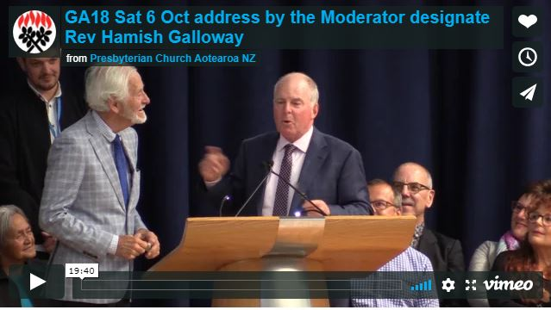

International guest speaker shares Australian Uniting Church issues
Today’s guest speaker Rob Floyd has been attending Assembly all week. Rob is associate general secretary of the United Church of Australia and this morning he shared with commissioners the key issues his church is grappling with and the decisions they’ve recently made.
Rob has served as associate general secretary since July 2017. He leads a small, multi-disciplinary team responsible for a range of national work including doctrine, worship, justice, standards for theological education and support of culturally and linguistically diverse communities.
As part of the UCA’s organisational changes, Rob and his team are developing new ways for people to engage in the work of the church nationally.
Rob initially trained and working as a teacher. He spent seven years living in Indonesia as a mission co-worker, taught at a Christian university, and supported a Christian micro-finance organisation. On his return to Australia, he worked for 11 years in UnitingWorld, the UCA’s international partnerships agency, which included a three-year term as the National Director.
Watch the video of Rob’s address:
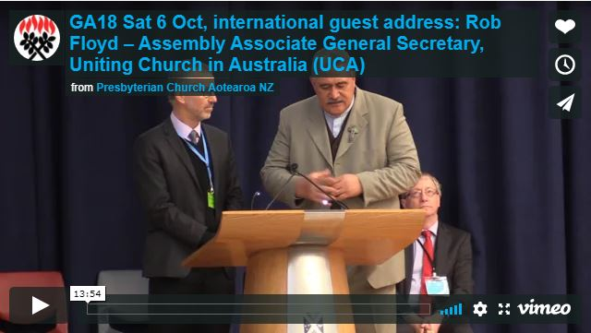

Very Rev Ray Coster speaks on the World Council of Churches
The Very Rev Ray Coster addressed the General Assembly about the World Council of Churches (WCC) 70th anniversary and the work the Council undertakes. Watch the video.
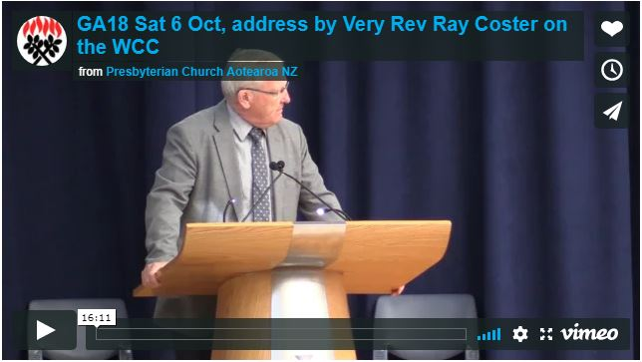

Code of Ethics
Commissioners at General Assembly expressed a desire for the reach of the Code of Ethics to extend to all church volunteers and employees.
This was among the themes reported back from dialogue groups by Rev Hamish Galloway.
Dialogue groups also indicated that providing cultural context was relevant and needs to be considered in the Code. Feedback from dialogue groups strongly commended the work done on the Code and noted that it was important to the life and work of the Church.
Assembly asked Council of Assembly to establish a workgroup to develop ways for ministers, employees and volunteers working in the church to have regular engagement with the Code through things like discussion, training, education, orientation and induction processes, profile on the Church’s website, and inclusion in contracts and supervision agreements.
In response to concerns about the financial liabilities faced by church officers under the Health and Safety at Work Act (2015) and the relative liabilities of volunteer workers under the Act, Assembly asked that the matter be referred to the Council of Assembly with a view to raising risk awareness.

Youth Commissioner profile
Each day of General Assembly we profile a presbytery Youth Commissioner.

Lucy Prestidge - GA youth commissioner, The Southern Presbytery
GA youth commissioner Lucy Prestidge says that for many young people raised in Christian families, leaving home is a significant time in forging faith and church commitments - apart from parents’ influence.
“This has certainly been true for me, and these last three years at university I’m grateful to have been surrounded by committed Christian friends and faith communities, of all flavours and denominations, who have shown me much of what it means to follow Christ individually and as a body.
"I’ve been greatly interested in understanding what distinguishes and what unites us. Therefore, I had two motivations for wanting to be a youth commissioner: I’d like to have a better grasp of what it particularly means to be Presbyterian and what the inner-workings of this Church look like. Despite having been part of it my whole life (and as a PK, no less) I have a lot more to learn!
“Secondly, and more importantly, I believe that no matter what denomination I find myself in, it is my privilege and responsibility as a disciple to be part of the fabric of the Church, and not just a consumer of whatever it might offer me. We all have different threads we can bring to this fabric, and I hope I’m right in thinking that whatever mine are - including, but hopefully not only, my perspective as a young adult - might be put to good use.”

Alpine Presbytery knits a community
Alpine Presbytery’s new moderator Rev Anne Stewart led today’s report from a still-youthful presbytery.
“Five years in, our primary goal,” Anne said, “Is to work on our culture – less institution and more about community and family. We’re committed to developing a sound and healthy culture based on good relationships.”
Currently, 25 percent of Alpine’s 59 parishes are technically vacant but some are led by shared ministry teams or resourced by neighbouring parishes.
“People lament to me sometimes that their minister is away assisting neighbouring parishes,” Anne told Assembly, “but we do it because someone in the family needs a helping hand. It’s just what you do and it’s been heartening to hear the Moderator talk this week about family.”
Although challenges abound with capacity issues and the rising tide of compliance, the Alpine Mission Fund has received a great act of generosity from its neighbour St Andrew’s at Rangi Ruru in Christchurch.
“The $3 million honours the spirit of generosity, of giving beyond parish borders,” says Alpine executive officer Barry Ayers. “This legacy gift means many projects can be supported and initiated to secure our future growth.”
Resource minister Darryl Tempero praised the growing team of mission discernment coaches who have already gone into 22 congregations to help them find their way in a changing missional context of rising costs and shrinking membership.
“Churches often realise the challenge but all too often don’t have a helpful, robust process to clarify their thinking before deciding what they should do,” explains Darryl. “We’re also learning from the process.”
Moderator Rt Rev Fakaofo Kaio embraced the presbytery team and acknowledged the shared journey of restructuring. He thanked Alpine especially for hosting Assembly with a smile this week, and all that task entails.

Assembly supports a leading role for InterChurch Bioethics Council
Assembly today supported a proposal that presbyteries and national groups be encouraged to invite the InterChurch Bioethics Council (ICBC) and Enquiring Minds (formerly the Bioethics Roadshow) to lead discussion of bioethical issues at regional gatherings.
The council is an ecumenical, cross-cultural body whose mission is to increase church members’ knowledge and understanding of spiritual, ethical and cultural issues as they relate to biotechnology, so they can act in an informed manner.
With issues such as euthanasia, legalising marijuana and the impending explosion of artificial intelligence all demanding informed public debate and posing significant ethical dilemmas, the ICBC’s work is timely.
The council has made submissions on the End of Life Choice Bill. It is working on new study guides relating to organ donation and transplants, assisted reproductive technology and legalisation of marijuana for medicinal and recreational use. It has also participated in public meetings such as a euthanasia debate at Christchurch Cathedral in April earlier this year.
Enquiring Minds has engaged thousands of intermediate and secondary students in exploring the impact of these issues and others such as social media responsibility.
To get in touch with the ICBC and access its resources, go to www.interchurchbioethics.org.nz

Keynote address: Very Rev Dr Graham Redding
The Very Rev Dr Graham Redding gave today’s keynote speaker address.
Graham has been the Master of Knox College, Dunedin, since 2014. He is a former Moderator of our Church (2008-2010), was Principal of the Knox Centre for Ministry and Leadership (2007-2014), and is a former parish minister.
Graham has served the Church in a variety of capacities, including the Leadership Policy Group and the Doctrine Core Group.
He has a Doctorate through London University. He is the author of Prayer and the Priesthood of Christ in the Reformed Tradition, published in 2003.
Watch video of his keynote address:
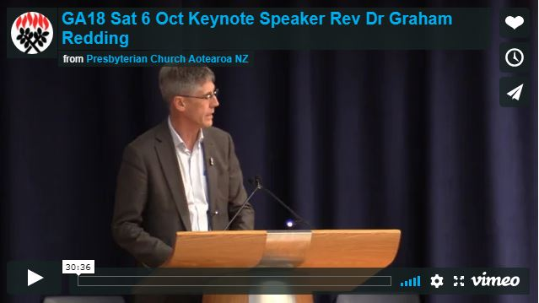

Assembly offers forgiveness for putting ecumenical relationships on the back burner
Assembly offered forgiveness to the Anglican Church for putting ecumenical relationships on the back burner.
The request for forgiveness was made by Anglican Archbishop Most Reverend Philip Richardson in his address to Assembly on Friday.
“Ecumenical partnerships have been on the back burner for too long,” said Archbishop Richardson. “I ask the Presbyterian Church’s forgiveness for our failures as partners in faith.”
Assembly received the request for forgiveness with humility and acknowledged that the Presbyterian Church was also in need of forgiveness for our part in that neglect.
Following the archbishop’s address, the Church’s Moderator Rt Rev Fakaofo Kaio led Assembly in prayer which offered forgiveness.
Today Assembly formally acknowledged the Moderator’s assurance of forgiveness that he made on behalf of Assembly in that prayer.
Rev Dr Selwyn Yeoman and the Very Rev Richard Dawson brought the proposal that asked Assembly to formally acknowledge the archbishop’s comments.
In his time as Moderator of the General Assembly Richard noted that he observed that the Church’s ecumenical relationships were not in great repair.
“I believe that offering forgiveness is a primary spiritual dynamic and it is appropriate that we accept this gracious offer of forgiveness from the archbishop and also record our offering of forgiveness,” said Richard.
After asking a few questions of clarification, commissioners voted in favour of acknowledging the Archbishop’s offer of forgiveness for putting ecumenical relationships on the back burner, and Assembly also sought forgiveness for its role in this.

New name and membership rules for Pacific Presbytery
Assembly approved changes to Book of Order membership regulations to improve the ability of individuals and groups to participate in the life of the Pacific Presbytery (formerly the Pacific Island Synod).
A review group set up by the Council of Assembly found that the early establishment of the Synod had been problematic. One of the main issues was that Book of Order membership regulations put up unintended barriers to participate in the life of the Presbytery and didn’t account for the many layers of membership that are lived reality of Pasifika peoples explained Margie Apa of the review group.
In commending the changes to Assembly, Margie said that the changes support the original aspirations that General Assembly had in mind when it established the Synod five years ago.
“The wording of the existing regulations had unintended consequences and restricted us in how we could do our life together,” said Margie.
Under new membership rules agreed to today, individuals or fellowship groups may join the Pacific Presbytery as associate members – even if their parish has voted not to join. This means that those within multicultural congregations now have an easy pathway to participate in the life of the Pacific Presbytery if they wish.
In response to questions of clarification it was confirmed that if someone chose to be associated with the Pacific Presbytery, they would remain under the oversight of their home presbytery and levies continue to be paid to the home presbytery.
Pacific Presbytery clerk Winston Timaloa, clerk of the Pacific Presbytery said that the changes provided people with choices.
“It opens other channels of working together. This makes it possible to participate in your home presbytery and in the Pacific Presbytery as well, if this is what you want.”
Before voting took place, commissioners sought clarification on what “associate” meant, and it was clarified that the Presbytery only has oversight of ministers who have chosen to be part of it, not all Pacific ministers.
Following the vote, Moderator the Rt Rev Fakaofo Kaio, described the Pacific Presbytery as the youngest member of the Church family and said: “As in all families, we need to look after each other. What we decided today will help the Presbytery play a bigger part in the Church family”.
General Assembly also affirmed a change of name for the Synod, which will from now on be known as Pacific Presbytery.
“We were given the status of presbytery five years ago, and the change honours the past and helps build a pathway for the future,” said Winston.
When asked why the name change was needed Winston advised that the new name better signalled their decision-making capability.

Refreshing the roots of doctrine
Assembly today agreed to commend the ongoing commemoration and study of the 500th anniversary marking the start of the Reformation.
In proposing the recommendation, the Doctrine Core Group said that a focus on the Reformation at this time of celebrating Luther’s posting of his 95 Theses critiquing indulgences encourages understanding of the faith and helps build good relationships with other Christian churches.
“We don’t need to look further afield. There are commemorative events taking place here in New Zealand which offer an opportunity for churches to refresh and develop our understanding of our historic roots, to explore our faith and consider how we relate Christian faith to our own, very different context,” explains convenor Rev Dr Stuart Lange.
In the spirit of relationship building, Assembly was also asked to agree with re-interpreting the Reformed Faith’s attitude to the Catholic Church’s beliefs and practices.
“Peace doesn’t just happen,” says Amber Parry, who proposed two recommendations today. “Peace has to be created over and over again.”
Assembly approved that statements within the Westminster Confession of Faith relating to monastic vows, the Pope, inter-denominational marriage and the Catholic Mass are to be seen in their historical context, not in the light of today’s much better respect and stronger relationships between the Presbyterian Church of Aotearoa New Zealand and the Catholic Church.
“Everyone would agree that those fiery clauses represent a very different time and place,” says Stuart.
The ‘Important Note’ on the Church’s website will be replaced with the following:
NOTE: The historic Westminster Confession of Faith (1646) is one of the subordinate standards of the Presbyterian Church of Aotearoa New Zealand, along with the contemporary Kupu Whakapono (2010).

Study book rejected
Today Assembly decided that it would not request presbyteries to facilitate the purchase, distribution and study of the book Changing our Minds by Prof David Gushee. The recommendation had sought that the book be available in all local parishes and that parishes to be urged to take up its study, and, wherever possible, combine with a neighbouring parish with differing viewpoints.
In presenting the proposal to Assembly, the Rev Dr Susan Jones said she had a deep respect for evangelical Christians who want to pay careful attention to Scripture and who seek to protect the quality of intimate human relationships. She indicated that she shared these concerns.
Susan pointed out that the Presbyterian Church is now different from society, different from the Church of Scotland and different from the Uniting Church of Australia, on considering matters that affect LGBTQ in churches and the community.
“One third of people walked out of Assembly a few years ago over how we discussed this issue. And in the intervening years, we haven’t come up with a better method. This proposal provides us with a different way of looking at this issue,” Susan said.
There was some debate on the proposal, with a number of commissioners seeking to speak for or against.
Two commissioners told how church rejection of homosexual young people is the cause of youth suicide. Another asked Assembly to remember that “we are all equal within God’s eyes…Jesus loves sinners too”.
It was suggested that as the book is biased, a more balanced approach could be taken via a second book with alternative scriptural interpretation being recommended for study also.
The Rev Dr Emma Keown said that the Presbyterian Church has been studying and debating issues of sexuality for 27 years. She said that since 1991 the Church has not wavered in its “decision that marriage is between a man and woman”.
The Rev Dr Susan Jones responded that there was no claim made that the book was unbiased, “it is the story of one evangelical facing these issues in his life”. She also said there was nothing to prevent churches studying other books alongside the book.

Church to get a Te Reo Commissioner
Assembly agreed to appoint a Te Reo Maori Commissioner to promote and extend the use of the Maori language within the Church.
“A commissioner is a practical way to build our Te Reo capacity,” said Rev Andrew Harrex from Southern Presbytery which brought the proposal to Assembly.
“This will be a great gift to all of us who are keen to develop our Te Reo skills, but are a bit scared or perhaps don’t know where to start,” said Andrew.
Marina Rakuraku, Moderator of Te Aka Puaho, seconded the motion and indicated that the commissioner would ideally be a people person and have knowledge of the geography of Aotearoa and all of its tribes.
The commissioner would be an encourager, and could source resources to be shared and used, said Andrew, who also noted that providing pathways to increase use of Te Reo within the Church recognised our bicultural partnership with Te Aka Puaho.
Commissioners warmly welcomed the proposal saying that they would appreciate additional resources to support Te Reo use during their worship.
In response to questions of clarification about how the role would be funded, Andrew responded that the commissioner didn’t necessarily have to be a paid position, and that it would be up to Council of Assembly and Te Aka Puaho to scope and appoint someone to the role.

Reduce, reuse and recycle
The Presbyterian Church has made a commitment to reduce its impact on the environment, and acknowledged the important role we play as Christians in caring for creation.
Assembly asked that all church councils, church schools and social service agencies connected with the Church implement three achievable and measureable acts of waste reduction and recycling.
Assembly endorsed three key actions to be sent to all parishes which included eliminating the use of disposable, single use items like Styrofoam cups and plastic straws, cups, and cutlery, and adopting the use of environmentally-friendly cleaning products, soaps and dishwashing liquids. Making recycling bins readily available was also supported by Assembly.
Assembly also agreed that progress toward implementation of the actions be reported in congregations’ annual reports to presbytery.
Brett Reid and Nadia Ridsdale, who presented the proposal on behalf of Presbytery Central, said that the Church needs to express its mission of care for creation.
“These are small and simple changes. Together we can make a difference. We hope that our changes will have a ripple effect and influence individuals and others in our community,” said Brett.
Nadia noted that they had engaged with Ecostore, who was willing to offer parishes special rates to purchase environmentally sustainable alternatives.
Some commissioners questioned the prescriptive nature of the recommendations saying that they didn’t adapt to the life of each congregation. Others sought clarity about the net environmental impact of supposedly sustainable things like removing away from single-use items. In response to questions of clarification, Nadia confirmed that the measures were not compulsory for congregations, but were desirable.
Most commissioners spoke strongly in favour of the need for congregations to be active stewards of creation and commended Presbytery Central for bringing the proposal.
Assembly agreed to a subsequent recommendation to expand the list of other environmentally-friendly changes in the Presbytery Central’s report to Assembly. Brett clarified that these were extra things that parishes could consider doing and weren’t part of the core list of actions to be sent to parishes.
The list of additional activities added several transport related actions that parishes could take to reduce their environmental footprint:
- Reduce transport related atmospheric carbon inputs by encouraging participation in local congregations and sharing together in the revitalisation of congregations.
- Promotion of cycling by the public provision of cycle stands
- Use church land (or make it available to community groups) for community gardens and/or restoration plantings.

Southern Presbytery a global Church
Southern Presbytery is now eight years old and, like other presbyteries, is undertaking its most thorough review since being established, in the face of declining numbers and increased workload.
Of a population of 323,000, there are 5,000 Presbyterians in the presbytery boundaries. There are 73 parishes and 47 ministers, which means a number of churches are without a settled ministry. The presbytery’s only source of income is levies on parishes so that places limits on the ability to fund all its activities.
Despite these challenges, the presbytery is being invigorated by multicultural members. Queenstown in particular has a global community, with 70 Brazilians adding South American enthusiasm to worship. The combined St Pauls (Oamaru) Maheno Otepopo Church is now 40 percent Pasifika.
Te Anau’s minister Craig Allan has found himself unexpectedly engaging in the Jesus in fellow Southland blokes who volunteer alongside him as fire fighters.
On a more formal basis, moderators of Southern Presbytery and the Synod of Otago and Southland called the presbytery team to a week of prayer focusing on significant reform of the relationship between these two bodies.

Kaimai Presbytery takes to the streets
Kaimai’s primary challenge is geographical distance. The presbytery extends along both sides of the Kaimai ranges to Lake Taupo and Taumaranui in the south. The half-yearly presbytery gatherings are the main means of drawing people together physically. Ministers also meet for lunch once a week and Rev Mark Maney from Mt Maunganui says these meals are good for nourishing the spirit as well as the body, and time well spent.
The presbytery’s strategic planning is a work in progress, with searching questions being asked about resources, leadership and parish health. Hard decisions are having to be made about limited finances. Despite that, some congregations are forging ahead with building renovations and extensions, while others are finding creative ways to do multicultural ministry in the streets. Rev Chris Barnard spoke about the community gardens project in Taneatua, which now provides vegetables for every household in one street, and more streets clamouring to join. The project is flourishing, with chickens, calves and piglets, sheds and chicken runs.
Looking outwards, the presbytery has raised funds for the rebuild of damaged buildings on Tanna Island in Vanuatu.

Presbytery Central shares its legacy
Executive secretary Peter McKenzie spoke to Assembly on behalf of Presbytery Central. Wearing a kilt, he talked about his recent time in Caithness in the Scottish Highlands and how it has informed both his perspective on the Church’s Scottish legacy and the two commitments he returned with. Presbyteries need to have the advantages of scale, and rural communities desperately need resourcing. We shouldn’t base our Churches on city life, he says.
Presbytery central employs 10 staff. One of its newer employees is a mission catalyst whose role is to dream big and “stir the pot”, working with local churches to define their plans for mission and ministry. Children and families’ ministry is being supported by three part-time enablers to encourage a wider generational influence. The executive secretary role has also been strengthened to provide administration support because, as Peter says, “we are called by God to Administry”.
Staff are paid from legacy funds that were wisely invested from properties bequeathed and sold over time. One property the presbytery decided not to sell when it closed was St Martin’s in Porirua. This year, the newly renovated buildings were passed onto Wellington Cook Island Church in a heartfelt celebration. As part of being responsible property owners, the strengthening of other earthquake prone buildings still dominates the discussions of many local churches.

Young adult commissioners at Assembly
Assembly agreed to replace the term youth commissioner with young adult commissioner in the Book of Order regulations relating to Assembly commissioners.
In commending the proposal to Assembly, Caleb Griffith, said the term youth commissioner was confusing and people often incorrectly assumed that commissioners worked with youth, represented the views of youth or were youth themselves.
He also highlighted that in the church environment, “youth” typically referred to someone between the ages of 12 and 24, and few young adult commissioners meet that criteria.
“We are university graduates, parents, and business owners. We don’t consider ourselves ‘youth’,” said Caleb.
Young adult commissioners are aged between 18-30, and it was suggested by one person during question time, that this could be expanded to include 16 and 17-year-olds.
Another asked what term was used by the World Council of Churches to describe their youth commissioners. Caleb responded that they felt the term “young adult” suited our context.
The proposal attracted minimal debate, and Assembly readily agreed to the change in terminology for young adult Assembly representatives.

NOTE: There is no Assembly business on Sunday 7 October. Assembly concludes Sunday morning with a closing service and communion at St Andrew's Centennial Chapel.

