PCANZ Overseas Travel Insurance Guide
- Frequently Asked Questions
- Policy
- Sample Claim Form

Who is covered under the PCANZ Corporate Travel Insurance policy?

The Corporate Travel Insurance policy includes any person authorised by PCANZ to travel overseas under this policy. The policy covers, for example:

- Ministers
- Employees
- Directors
- Close family
- Volunteers

of/for the Presbyterian Church of Aotearoa New Zealand (PCANZ), including presbyteries, Synod of Otago and Southland, Te Aka Puahou, and churches (including cooperating ventures).

Close family includes husband, wife or partner, and dependent children under 18 years old.

Volunteers include people from across the wider Church travelling overseas to undertake unpaid mission work, build schools or other activities.

- Domestic travel insurance is not available through the Assembly Office.

Is there a charge?
Yes, the daily charge for international travel is $10 per day (GST does not apply). Travellers will be invoiced by the Assembly Office prior to travel.

Who is our insurer?
Berkshire Hathaway Specialty Insurance (BHSI), arranged through Gallagher

What types of travel are covered?
The policy covers:

- work-related overseas travel including associated private, personal and family travel outside New Zealand.

For the main traveller, more than 50% of the trip must be work-related, but can be accompanied by some personal travel on the same trip as long as that is less than 50% of the entire trip.

What benefits are available under the Travel policy?
Refer to the attached policy schedule (Appendix 1) for benefits, sums insured and excesses. Please note that the domestic travel benefit are not available through the Assembly Office.

Is there an Age Limit on travellers?
Yes, 80 years old. And destination restrictions apply to those aged 70-80 years old – see FAQ 9.

Is cover automatic, or do you need to apply for it in advance?
The Corporate Travel Insurance policy includes any person authorised by PCANZ to travel under this policy.

However, an application for the travel cover must be made in advance to the PCANZ Assembly Office and confirmed in writing by the Assembly Office, e.g., by email and will be recorded in the PCANZ Travel Register.

When you wish to be covered under the PCANZ Corporate travel insurance policy, you must complete and submit this online form in advance (to the Assembly Office). For queries about the form (and not the insurance cover) please contact the Office Manager at the Assembly Office, Nani Susijanto at nani@presbyterian.org.nz

How many days are we covered for on One Single Trip?
180 days maximum. See Policy Schedule for definition of journey.,

If your trip will be more than 180 days please contact Gallagher for a separate quote as your trip will not be covered by this policy. You are not able to cover 180 days under this policy, plus another policy for the remaining days.

As noted in FAQ4 above, for the main traveller, at least 50% of the trip must be work-related.

Are there any restrictions on international travel?
Yes. The policy does not cover trips undertaken to countries covered by sanctions at the time of booking. International destinations are limited for those over 70 years of age, and insurance for anyone over 80 years of age is not available (unless on request to Gallaghers).

Overseas travel for an Insured Person aged seventy (70) and seventy-one (71) years is limited to Australia, the Pacific Islands (excluding Hawaii or any US Territories), and Asia only,

Overseas travel for an Insured Person aged between seventy-two (72) and seventy-nine (79) years means a trip authorised by the Policyholder, provided such trip involves a destination limited Australia, and the Pacific Islands (excluding Hawaii or any US Territories)

Please check the New Zealand Ministry of Foreign Affairs and Trade (MFAT) website for any travel advisories or warnings. Refer: https://www.safetravel.govt.nz

What should I do before making travel arrangements I want to be covered by the PCANZ travel insurance policy?
- Check the MFAT website for travel advisories and warnings https://www.safetravel.govt.nz
- Declare tentative travel plans (as soon as they are known) to the Assembly Office
- Complete and submit this online form (to the Assembly Office). For queries about the form (and not the insurance cover), please contact the Office Manager at the Assembly Office, Nani Susijanto at nani@presbyterian.org.nz

Are Pre-Existing Conditions covered?
Your pre-existing medical conditions are automatically covered under the policy as long as:
- Your journey is not undertaken against the advice of a doctor, the insured person is fit to travel and the insured person is not travelling to seek medical attention; and
- You are not suffering from a terminal condition which was diagnosed prior to the journey by a doctor, but only in respect of the terminal condition.

Note: BHSI does not cover claims and costs incurred:
- for any medication for a condition that commenced prior to the commencement of a journey and the insured person has been advised to continue the medication during the journey,
- for routine or elective medical, optical or dental treatment or consultation,
- after the period of 24 months from the date the insured person dies or suffers a sickness or injury,
- for ongoing medical expenses after 24 months from the date of the injury or sickness. In respect of any insured person who is domiciled outside of New Zealand, there will be no cover for ongoing medical expenses back in their country of usual residence that are in excess of $50,000 or after 24 months from the date of the injury or sickness, whichever calculation produces the lesser amount.

Is there a limit on Medical Expenses incurred during travel?
No, it’s unlimited.

Will I get a refund if I cancel my travel arrangements (flight tickets and hotel reservations) due to unforeseen medical condition(s)?
Yes, however, the claim must be supported by a Medical Certificate confirming that you were unfit to travel.

Does the policy cover Rental Vehicles taken up during travel?
For insurance cover on the excess for vehicles rented overseas, please contact Jeffery Nathan, at Gallagher Insurance, jeffery.nathan@ajg.co.nz

What should I do in the event of an emergency or uncertainty on what steps to take during my travel?
In an emergency or if you uncertain about next steps, please contact:

BHSI Care and Concierge can be contacted by an Insured Person anytime, anywhere in the world, without any additional charge to the Insured Person, by calling +64 9 356 2320.

BHSI Care and Concierge can assist with the following:
- Emergency travel assistance.
- Emergency medical evacuation
- Payment of evacuation expenses, including necessary expenses incurred for qualified medical staff to accompany an insured person.
- Medically supervised repatriation.
- Repatriation which will be organised by Allianz Partners by the most appropriate method, including, if necessary, the use of air services.
- Assistance in replacing a lost or stolen passport.
- Legal assistance.
- Payment of other emergency assistance expenses.

How do I lodge a travel claim?
- Complete a Berkshire Hathaway Travel Insurance Claim Form (attached, Appendix 2)
- Attach any relevant receipts or supporting documentation and email to:

  - Church.Claims@ajg.co.nz copy to: jeffery.nathan@ajg.co.nz

Who do I contact if I have any questions about cover?

Jeffery Nathan
Senior Broker - Corporate
Gallagher Level 4, Gallagher Centre, 100 Beaumont Street, Auckland 1010
+64 9 356 1525 | +64 27 561 2565
jeffery.nathan@ajg.co.nz | ajg.co.nz

Appendix 1 – Policy Schedule
Appendix 2 – Sample Berkshire Claim form

Appendix 1 - Policy Schedule – Stand-alone domestic travel, not connected with international travel, is not covered

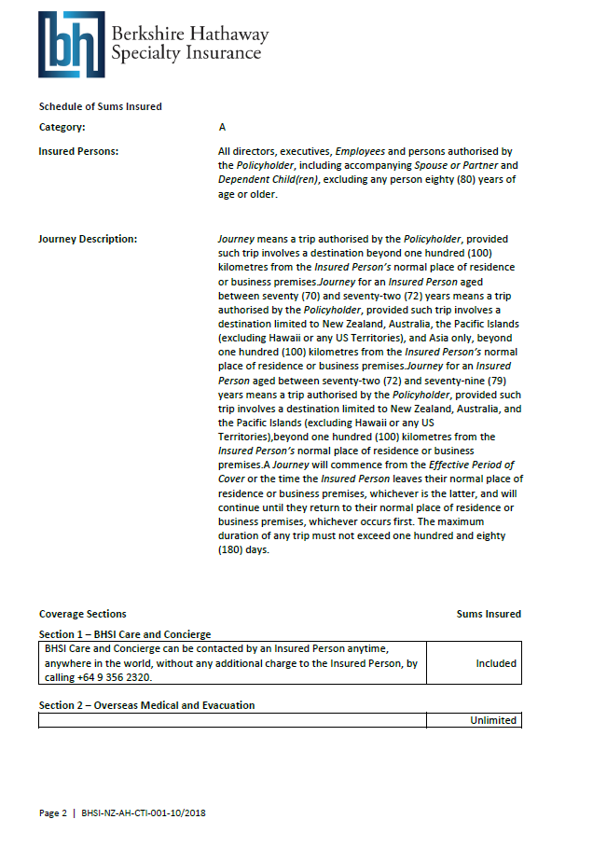

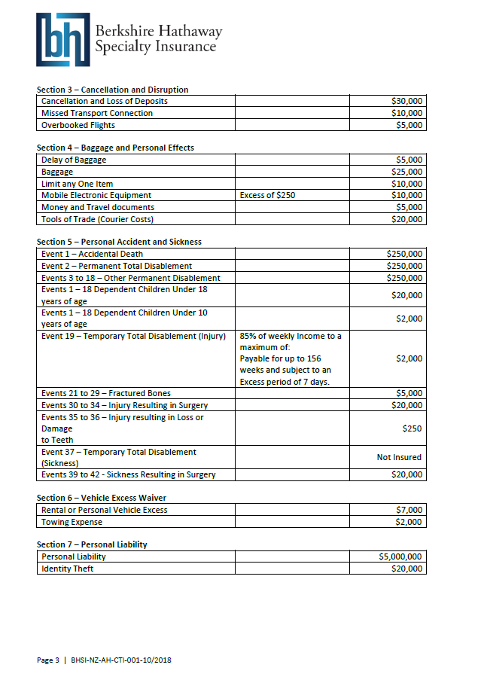
Section 6, Vehicle Excess Waiver – travellers must contact Gallager to request details and confirmation of overseas vehicle excess waiver.

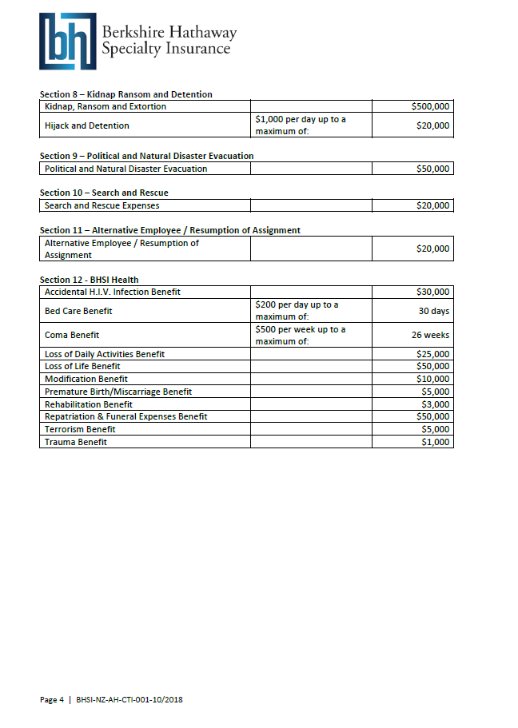

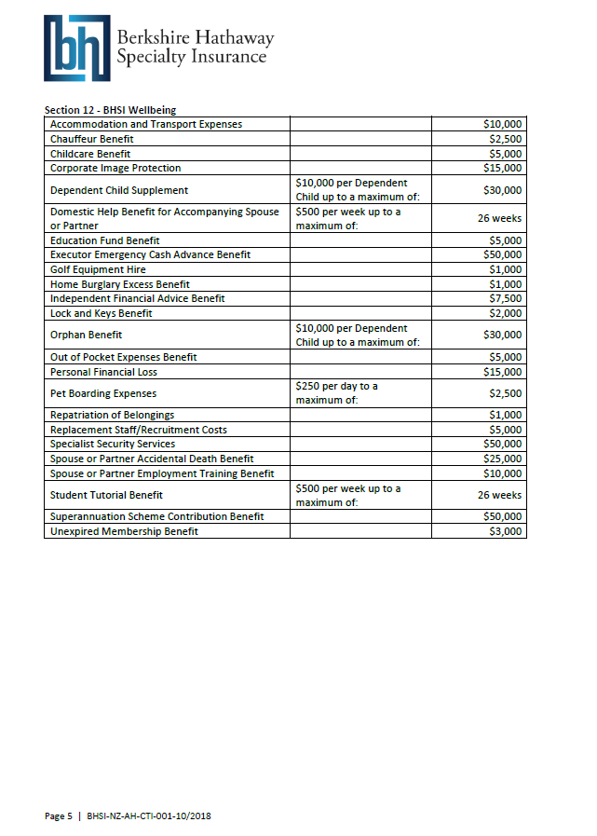

Appendix 2 – Sample Travel Claim form – in event of claim, please request original from Assembly Office

